**Dataset 1: PlantVillage**

**BASE MODELS**

**MODEL 1 – CNN**

***No. of Images in Train, Validation and Test Sets***

|  |  |
| --- | --- |
| Total No. of Images: 2152  *(Early Blight: 1000, Late Blight: 1000, Healthy: 152)* – 80:10:10 Split | |
| **Train** | 1728 |
| **Validation** | 192 |
| **Test** | 232 |

***Model Summary***

* Image Size: 256 x 256
* Batch Size: 32
* No. of Channels: 3
* No. of Epochs: 20

***Graph***

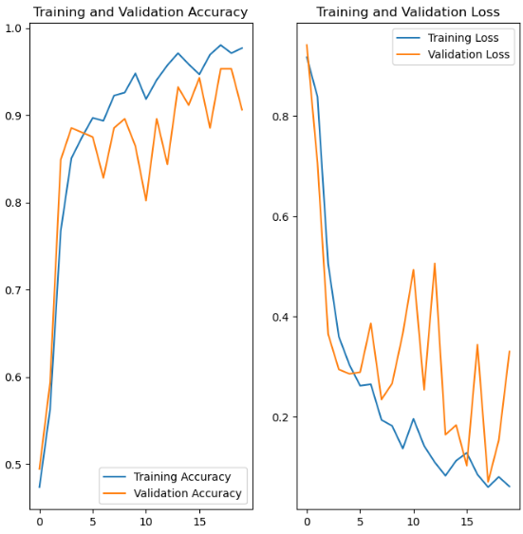

***Confusion Matrix***

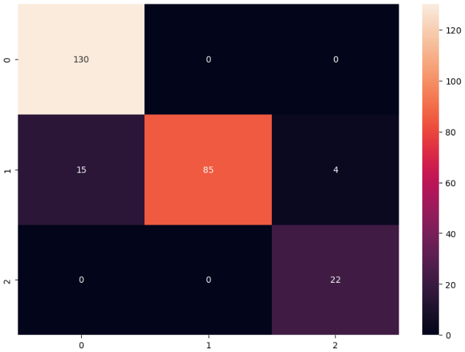

Misclassification Rate: 6.09 % (0.00%, 18.27%, 0.00%)

***Predictions***

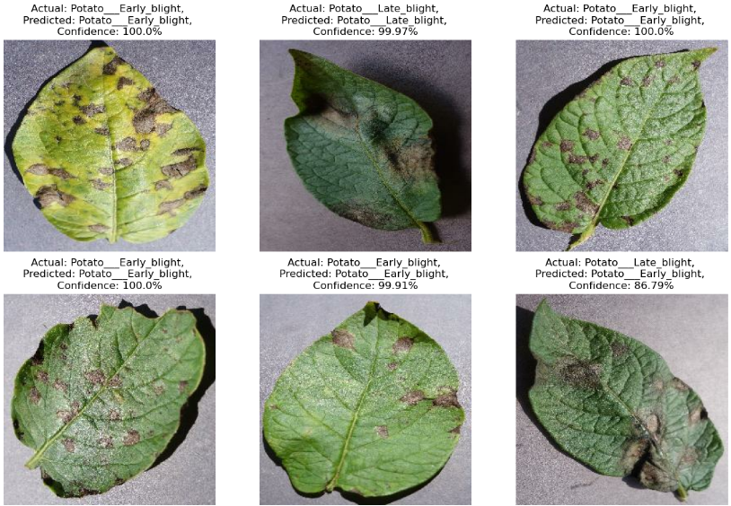

**MODEL 2 – ResNet50**

***No. of Images in Train, Validation and Test Sets***

|  |  |
| --- | --- |
| Total No. of Images: 2152  *(Early Blight: 1000, Late Blight: 1000, Healthy: 152)* – 80:10:10 Split | |
| **Train** | 1728 |
| **Validation** | 192 |
| **Test** | 232 |

***Model Summary***

* Image Size: 224 x 224
* Batch Size: 32
* No. of Channels: 3
* No. of Epochs: 5

***Graph***

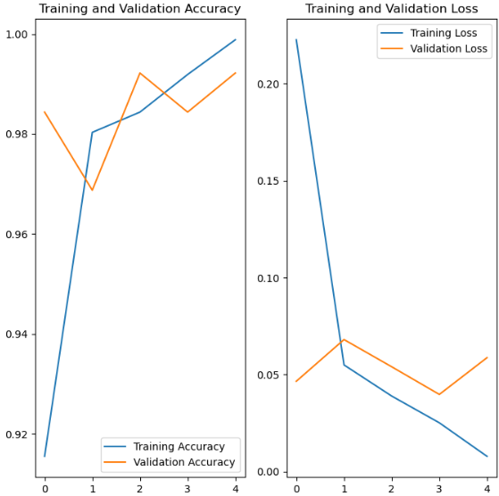

***Confusion Matrix***

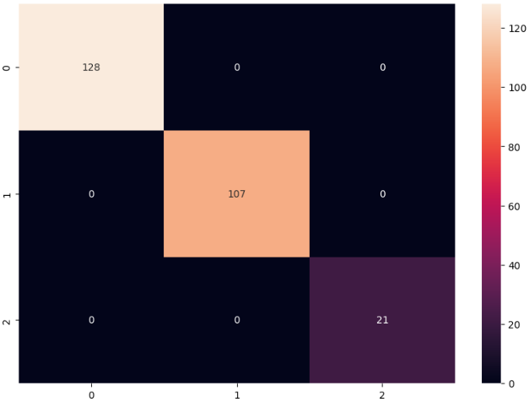

Misclassification Rate: 0% (0.00%, 0.00%, 0.00%)

**Predictions**

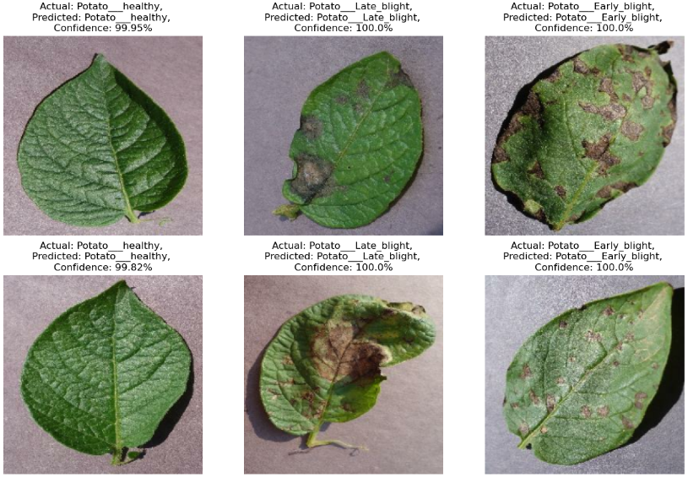

**MODEL 3 – VGG16**

***No. of Images in Train, Validation and Test Sets***

|  |  |
| --- | --- |
| Total No. of Images: 2152  *(Early Blight: 1000, Late Blight: 1000, Healthy: 152)* – 80:10:10 Split | |
| **Train** | 1728 |
| **Validation** | 192 |
| **Test** | 232 |

***Model Summary***

* Image Size: 224 x 224
* Batch Size: 32
* No. of Channels: 3
* No. of Epochs: 3

***Graph***

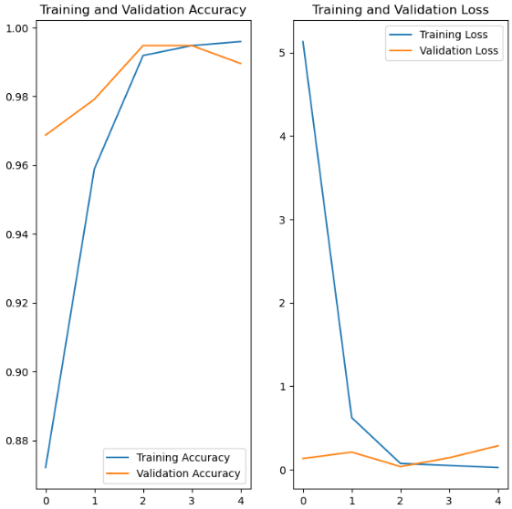

***Confusion Matrix***

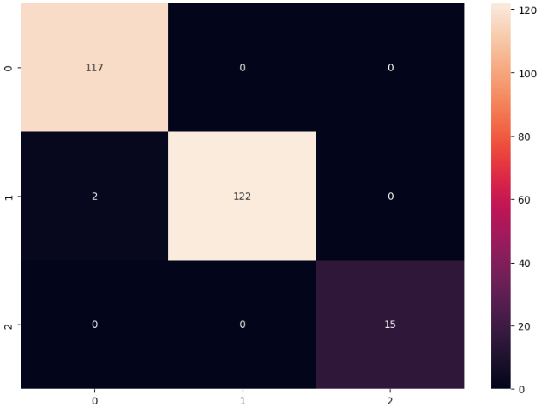

Misclassification Rate: 0.54% (0.00%, 1.61%, 0.00%)

***Predictions***

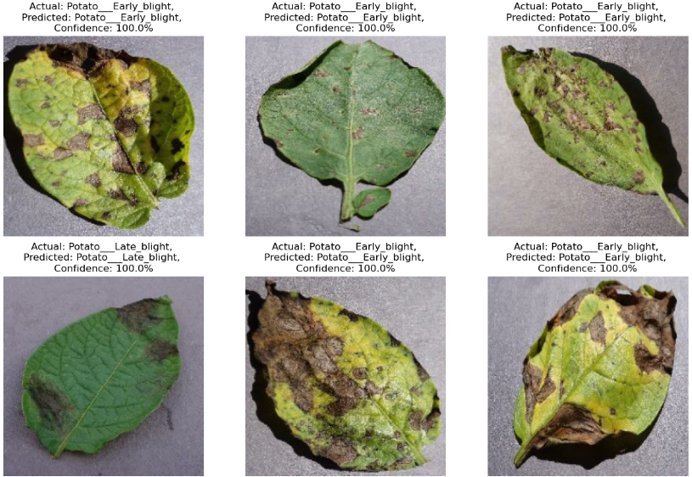

**MODEL 4 – VGG19**

***No. of Images in Train, Validation and Test Sets***

|  |  |
| --- | --- |
| Total No. of Images: 2152  *(Early Blight: 1000, Late Blight: 1000, Healthy: 152)* – 80:10:10 Split | |
| **Train** | 1728 |
| **Validation** | 192 |
| **Test** | 232 |

***Model Summary***

* Image Size: 224 x 224
* Batch Size: 32
* No. of Channels: 3
* No. of Epochs: 2

***Graph***

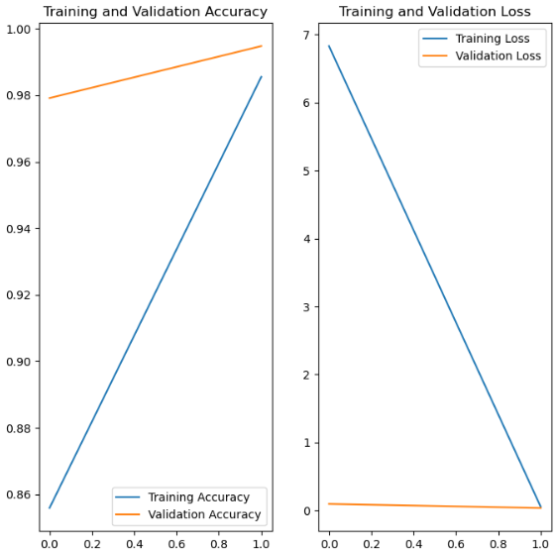

***Confusion Matrix***

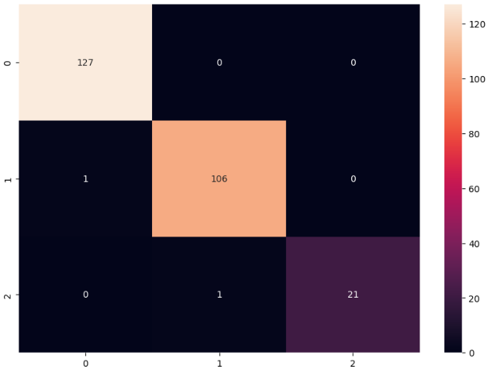

Misclassification Rate: 1.82% (0.00%, 0.93%, 4.54%)

***Predictions***

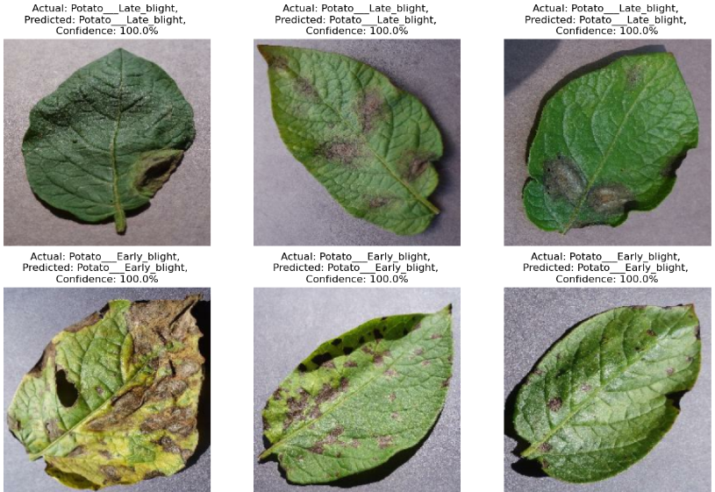

**MODEL 5 – InceptionV3**

***No. of Images in Train, Validation and Test Sets***

|  |  |
| --- | --- |
| Total No. of Images: 2152  *(Early Blight: 1000, Late Blight: 1000, Healthy: 152)* – 80:10:10 Split | |
| **Train** | 1728 |
| **Validation** | 192 |
| **Test** | 232 |

***Model Summary***

* Image Size: 224 x 224
* Batch Size: 32
* No. of Channels: 3
* No. of Epochs: 15

***Graph***

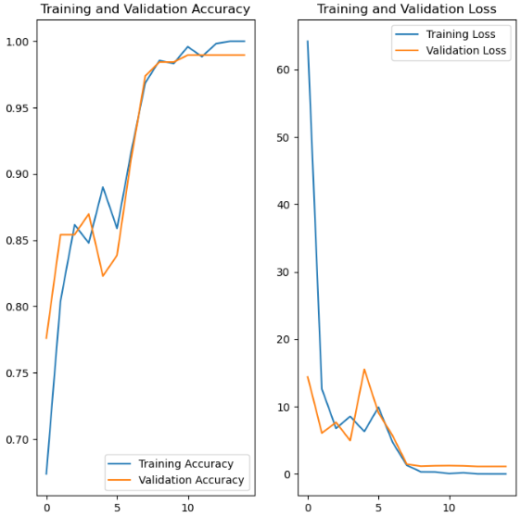

***Confusion Matrix***

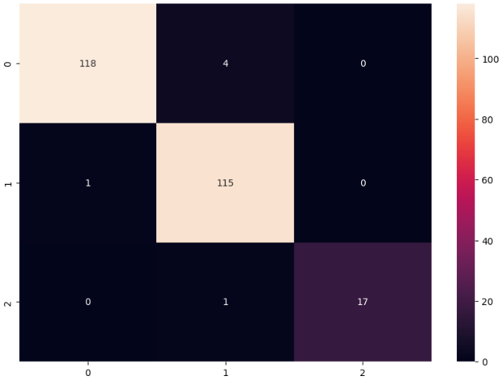

Misclassification Rate: 3.23% (3.28%, 0.86%, 5.56%)

***Predictions***

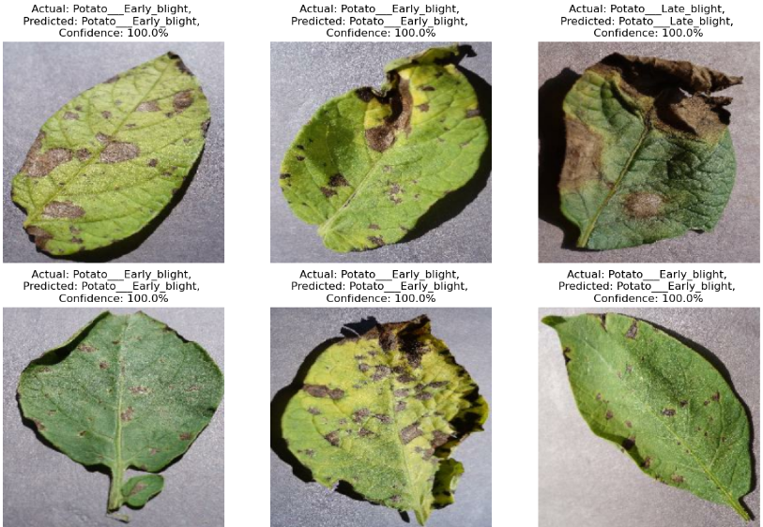

**MODEL 6 – AlexNet**

***No. of Images in Train, Validation and Test Sets***

|  |  |
| --- | --- |
| Total No. of Images: 2152  *(Early Blight: 1000, Late Blight: 1000, Healthy: 152)* – 80:10:10 Split | |
| **Train** | 1728 |
| **Validation** | 192 |
| **Test** | 232 |

***Model Summary***

* Image Size: 224 x 224
* Batch Size: 32
* No. of Channels: 3
* No. of Epochs: 20

***Graph***

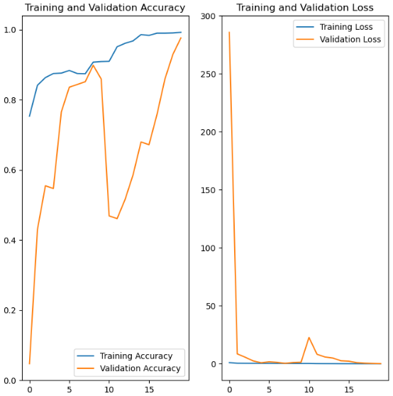

***Confusion Matrix***

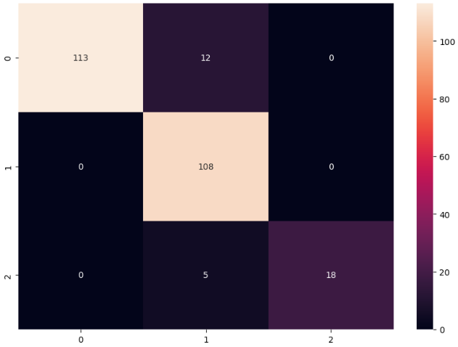

Misclassification Rate: 10.45% (9.60%, 0.00%, 21.74%)

***Predictions***

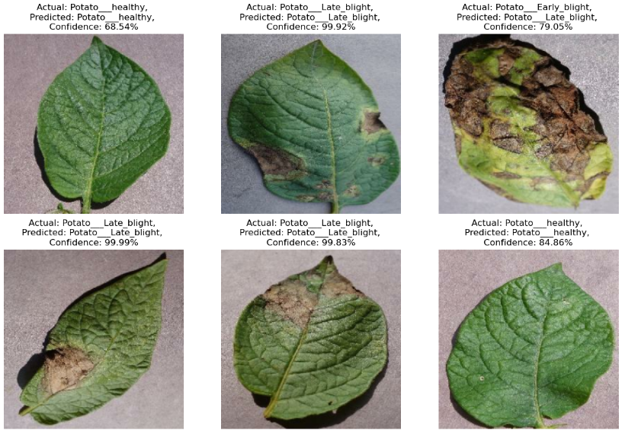

**COMPARISON OF BASE MODELS**

***Average Time per Epoch***

* Model 1 – CNN: 71.30 s
* Model 2 – ResNet50: 103.00 s
* Model 3 – VGG16: 301.80 s
* Model 4 – VGG19: 319.50 s
* Model 5 – InceptionV3: 62.27 s
* Model 6 – AlexNet: 77.15 s

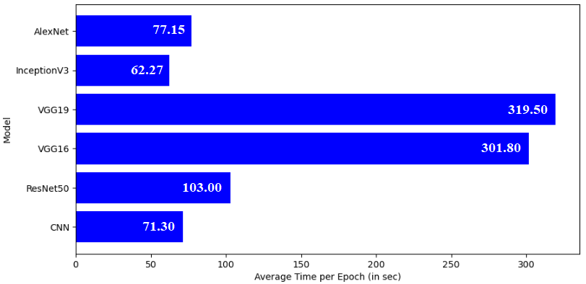

***Precision, Recall, f1 Score*** *(0: Early Blight, 1: Late Blight, 2: Healthy)*

|  |  |  |  |  |  |  |  |  |  |  |  |  |
| --- | --- | --- | --- | --- | --- | --- | --- | --- | --- | --- | --- | --- |
| **Model** | **Precision** | | | | **Recall** | | | | **f1 Score** | | | |
| **0** | **1** | **2** | **Weighted Average** | **0** | **1** | **2** | **Weighted Average** | **0** | **1** | **2** | **Weighted Average** |
| CNN | 0.90 | 1.00 | 0.85 | 0.93 | 1.00 | 0.82 | 1.00 | 0.93 | 0.95 | 0.90 | 0.92 | 0.92 |
| ResNet50 | 1.00 | 1.00 | 1.00 | 1.00 | 1.00 | 1.00 | 1.00 | 1.00 | 1.00 | 1.00 | 1.00 | 1.00 |
| VGG16 | 0.98 | 1.00 | 1.00 | 0.99 | 1.00 | 0.98 | 1.00 | 0.99 | 0.99 | 0.99 | 1.00 | 0.99 |
| VGG19 | 0.99 | 0.99 | 1.00 | 0.99 | 1.00 | 0.99 | 0.95 | 0.99 | 1.00 | 0.99 | 0.98 | 0.99 |
| InceptionV3 | 0.99 | 0.96 | 1.00 | 0.98 | 0.97 | 0.99 | 0.94 | 0.98 | 0.98 | 0.97 | 0.97 | 0.98 |
| AlexNet | 1.00 | 0.86 | 1.00 | 0.94 | 0.90 | 1.00 | 0.78 | 0.93 | 0.95 | 0.93 | 0.88 | 0.93 |

***Accuracy and Loss***

* Model 1 – CNN: 0.9258, 0.2212
* Model 2 – ResNet50: 1.0000, 0.0046
* Model 3 – VGG16: 0.9922, 0.1107
* Model 4 – VGG19: 0.9922, 0.0926
* Model 5 – InceptionV3: 0.9766, 1.5436
* Model 6 – AlexNet: 0.9336, 0.2237

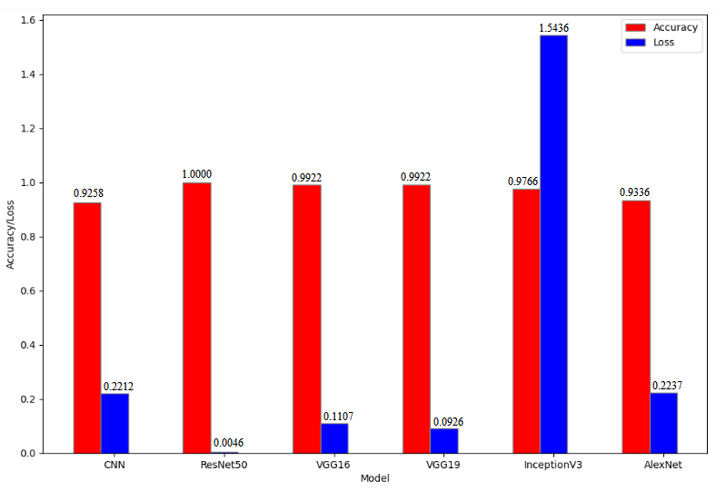

**MODEL COMPARISONS BASED ON NO. OF EPOCHS, BATCH SIZE AND DATASET SPLIT RATION**

**MODEL 1: CNN**

**No. of Epochs**

***Average Time per Epoch***

* 10: 74.30 s
* 20: 71.30 s
* 30: 70.57 s
* 40: 68.18 s
* 50: 70.34 s

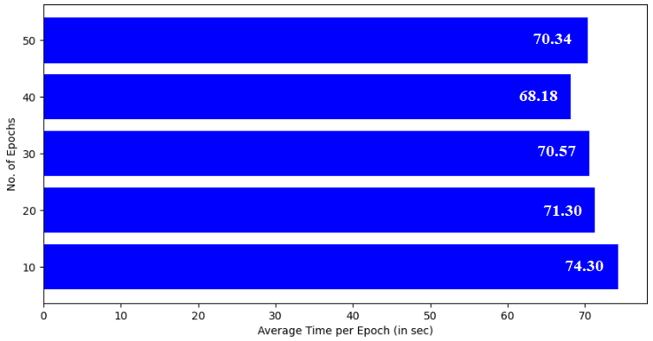

***Precision, Recall, f1 Score*** *(0: Early Blight, 1: Late Blight, 2: Healthy)*

|  |  |  |  |  |  |  |  |  |  |  |  |  |
| --- | --- | --- | --- | --- | --- | --- | --- | --- | --- | --- | --- | --- |
| **No. of Epochs** | **Precision** | | | | **Recall** | | | | **f1 Score** | | | |
| **0** | **1** | **2** | **Weighted Average** | **0** | **1** | **2** | **Weighted Average** | **0** | **1** | **2** | **Weighted Average** |
| 10 | 0.97 | 0.96 | 0.78 | 0.95 | 0.97 | 0.92 | 1.00 | 0.95 | 0.97 | 0.94 | 0.88 | 0.95 |
| 20 | 0.90 | 1.00 | 0.85 | 0.93 | 1.00 | 0.82 | 1.00 | 0.93 | 0.95 | 0.90 | 0.92 | 0.92 |
| 30 | 1.00 | 0.99 | 0.86 | 0.99 | 0.99 | 0.98 | 1.00 | 0.98 | 1.00 | 0.98 | 0.92 | 0.98 |
| 40 | 0.99 | 0.98 | 0.93 | 0.98 | 1.00 | 0.98 | 0.88 | 0.98 | 1.00 | 0.98 | 0.90 | 0.98 |
| 50 | 0.96 | 0.99 | 0.92 | 0.97 | 1.00 | 0.94 | 0.96 | 0.97 | 0.98 | 0.96 | 0.94 | 0.97 |

***Accuracy and Loss***

* 10: 0.9492, 0.1296
* 20: 0.9258, 0.2212
* 30: 0.9844, 0.0283
* 40: 0.9844, 0.0735
* 50: 0.9688, 0.1204

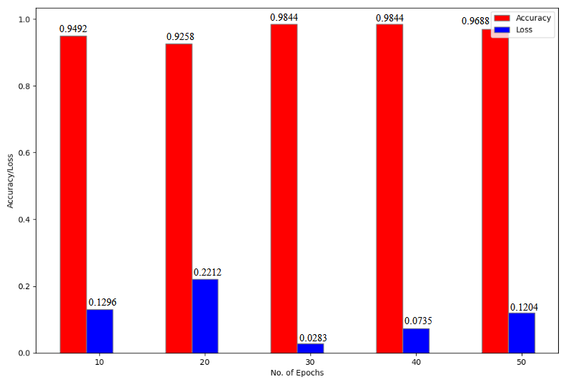

**Batch Size**

***Average Time per Epoch***

* 16: 73.05 s
* 24: 76.75 s
* 32: 71.45 s
* 40: 83.70 s
* 48: 73.00 s

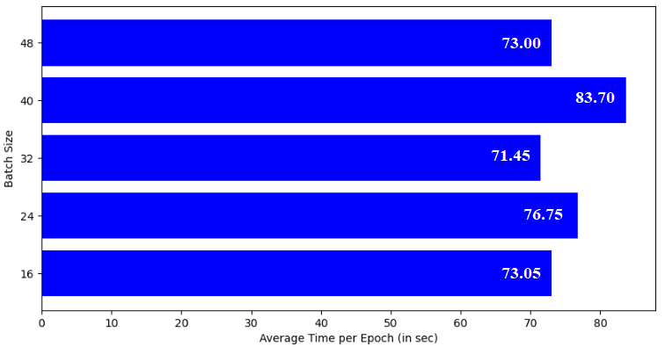

***Precision, Recall, f1 Score*** *(0: Early Blight, 1: Late Blight, 2: Healthy)*

|  |  |  |  |  |  |  |  |  |  |  |  |  |
| --- | --- | --- | --- | --- | --- | --- | --- | --- | --- | --- | --- | --- |
| **Batch Size** | **Precision** | | | | **Recall** | | | | **f1 Score** | | | |
| **0** | **1** | **2** | **Weighted Average** | **0** | **1** | **2** | **Weighted Average** | **0** | **1** | **2** | **Weighted Average** |
| 16 | 0.95 | 0.98 | 0.67 | 0.95 | 0.99 | 0.91 | 0.86 | 0.95 | 0.97 | 0.94 | 0.75 | 0.95 |
| 24 | 0.99 | 0.99 | 1.00 | 0.99 | 1.00 | 0.99 | 0.90 | 0.99 | 1.00 | 0.99 | 0.95 | 0.99 |
| 32 | 0.97 | 0.99 | 0.86 | 0.97 | 1.00 | 0.95 | 0.92 | 0.97 | 0.98 | 0.97 | 0.89 | 0.97 |
| 40 | 0.97 | 1.00 | 0.74 | 0.97 | 1.00 | 0.92 | 1.00 | 0.96 | 0.99 | 0.96 | 0.85 | 0.96 |
| 48 | 0.72 | 1.00 | 0.94 | 0.88 | 1.00 | 0.66 | 1.00 | 0.83 | 0.84 | 0.80 | 0.97 | 0.83 |

***Accuracy and Loss***

* 16: 0.9509, 0.1242
* 24: 0.9907, 0.0198
* 32: 0.9727, 0.0730
* 40: 0.9625, 0.1135
* 48: 0.8292, 0.7339

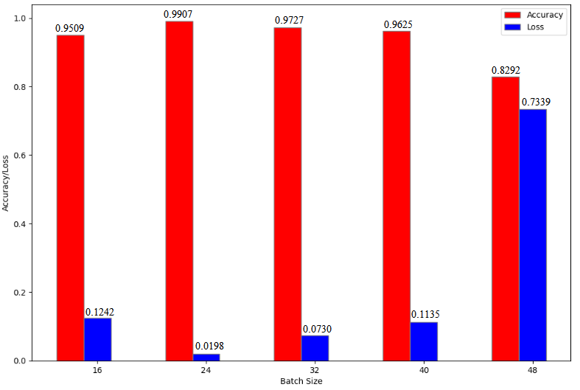

**Dataset Split Ratio**

***Average Time per Epoch***

* 90-5-5: 81.50 s
* 80-10-10: 71.20 s
* 70-15-15: 60.95 s
* 60-20-20: 53.40 s
* 50-25-25: 49.45 s

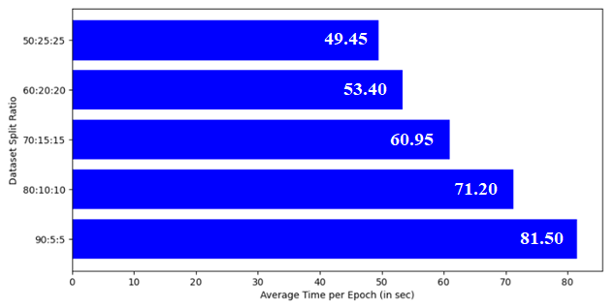

***Precision, Recall, f1 Score*** *(0: Early Blight, 1: Late Blight, 2: Healthy)*

|  |  |  |  |  |  |  |  |  |  |  |  |  |
| --- | --- | --- | --- | --- | --- | --- | --- | --- | --- | --- | --- | --- |
| **Dataset Split Ratio** | **Precision** | | | | **Recall** | | | | **f1 Score** | | | |
| **0** | **1** | **2** | **Weighted Average** | **0** | **1** | **2** | **Weighted Average** | **0** | **1** | **2** | **Weighted Average** |
| 90:5:5 | 0.82 | 1.00 | 0.88 | 0.92 | 1.00 | 0.80 | 1.00 | 0.90 | 0.90 | 0.89 | 0.93 | 0.90 |
| 80:10:10 | 0.91 | 1.00 | 0.91 | 0.95 | 1.00 | 0.89 | 1.00 | 0.95 | 0.95 | 0.94 | 0.95 | 0.95 |
| 70:15:15 | 0.92 | 0.99 | 0.93 | 0.95 | 1.00 | 0.90 | 0.96 | 0.95 | 0.96 | 0.95 | 0.94 | 0.95 |
| 60:20:20 | 0.98 | 0.97 | 0.82 | 0.96 | 0.97 | 0.95 | 0.94 | 0.96 | 0.98 | 0.96 | 0.87 | 0.96 |
| 50:25:25 | 1.00 | 0.89 | 0.92 | 0.94 | 0.89 | 0.99 | 0.95 | 0.94 | 0.94 | 0.94 | 0.93 | 0.94 |

***Accuracy and Loss***

* 90-5-5: 0.8984, 0.1881
* 80-10-10: 0.9492, 0.1412
* 70-15-15: 0.9517, 0.1144
* 60-20-20: 0.9604, 0.0922
* 50-25-25: 0.9393, 0.1538

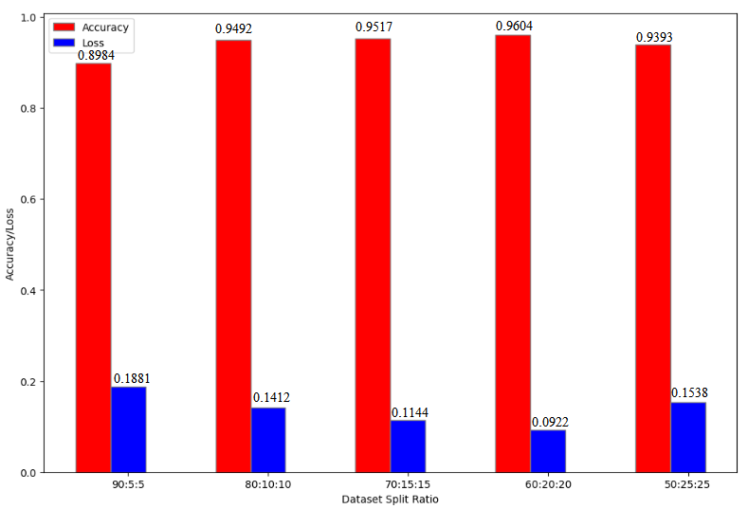

**MODEL 2: ResNet50**

**No. of Epochs**

***Average Time per Epoch***

* 2: 89.50 s
* 3: 92.00 s
* 5: 103.00 s
* 7: 104.28 s
* 10: 99.00 s

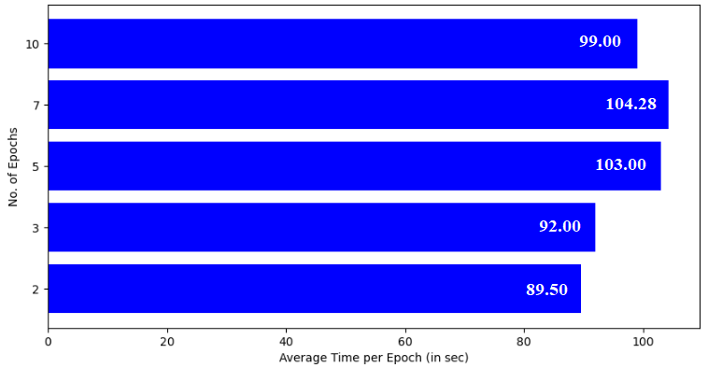

***Precision, Recall, f1 Score*** *(0: Early Blight, 1: Late Blight, 2: Healthy)*

|  |  |  |  |  |  |  |  |  |  |  |  |  |
| --- | --- | --- | --- | --- | --- | --- | --- | --- | --- | --- | --- | --- |
| **No. of Epochs** | **Precision** | | | | **Recall** | | | | **f1 Score** | | | |
| **0** | **1** | **2** | **Weighted Average** | **0** | **1** | **2** | **Weighted Average** | **0** | **1** | **2** | **Weighted Average** |
| 2 | 0.99 | 1.00 | 1.00 | 1.00 | 1.00 | 0.99 | 1.00 | 1.00 | 1.00 | 1.00 | 1.00 | 1.00 |
| 3 | 1.00 | 1.00 | 0.92 | 0.99 | 1.00 | 0.98 | 1.00 | 0.99 | 1.00 | 0.99 | 0.96 | 0.99 |
| 5 | 1.00 | 1.00 | 1.00 | 1.00 | 1.00 | 1.00 | 1.00 | 1.00 | 1.00 | 1.00 | 1.00 | 1.00 |
| 7 | 1.00 | 1.00 | 1.00 | 1.00 | 1.00 | 1.00 | 1.00 | 1.00 | 1.00 | 1.00 | 1.00 | 1.00 |
| 10 | 1.00 | 1.00 | 0.95 | 1.00 | 1.00 | 0.99 | 1.00 | 1.00 | 1.00 | 1.00 | 0.97 | 1.00 |

***Accuracy and Loss***

* 2: 0.9961, 0.0288
* 3: 0.9922, 0.0172
* 5: 1.0000, 0.0046
* 7: 1.0000, 0.0026
* 10: 0.9961, 0.0108

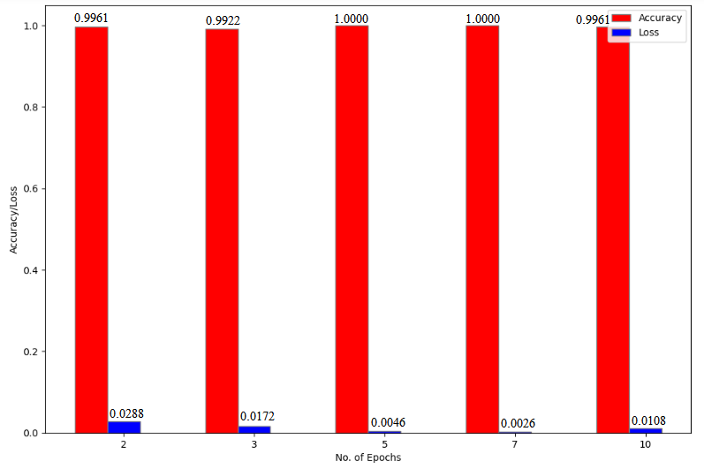

**Batch Size**

***Average Time per Epoch***

* 16: 115.20 s
* 24: 107.80 s
* 32: 113.60 s
* 40: 114.80 s
* 48: 113.60 s

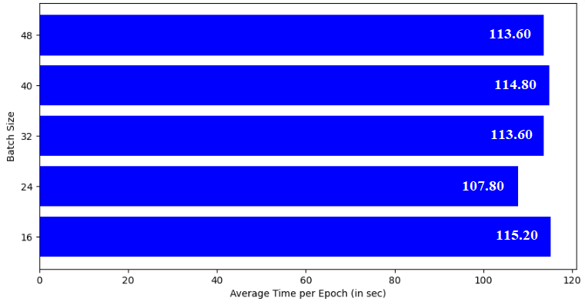

***Precision, Recall, f1 Score*** *(0: Early Blight, 1: Late Blight, 2: Healthy)*

|  |  |  |  |  |  |  |  |  |  |  |  |  |
| --- | --- | --- | --- | --- | --- | --- | --- | --- | --- | --- | --- | --- |
| **Batch Size** | **Precision** | | | | **Recall** | | | | **f1 Score** | | | |
| **0** | **1** | **2** | **Weighted Average** | **0** | **1** | **2** | **Weighted Average** | **0** | **1** | **2** | **Weighted Average** |
| 16 | 0.99 | 1.00 | 1.00 | 1.00 | 1.00 | 0.99 | 1.00 | 1.00 | 1.00 | 1.00 | 1.00 | 1.00 |
| 24 | 0.99 | 0.99 | 1.00 | 0.99 | 1.00 | 0.99 | 0.93 | 0.99 | 1.00 | 0.99 | 0.97 | 0.99 |
| 32 | 0.98 | 1.00 | 1.00 | 0.99 | 1.00 | 0.98 | 1.00 | 0.99 | 0.99 | 0.99 | 1.00 | 0.99 |
| 40 | 1.00 | 0.99 | 1.00 | 1.00 | 1.00 | 1.00 | 0.94 | 1.00 | 1.00 | 1.00 | 0.97 | 1.00 |
| 48 | 1.00 | 0.99 | 1.00 | 1.00 | 1.00 | 1.00 | 0.94 | 1.00 | 1.00 | 1.00 | 0.97 | 1.00 |

***Accuracy and Loss***

* 16: 0.9955, 0.0283
* 24: 0.9907, 0.0152
* 32: 0.9922, 0.0193
* 40: 0.9958, 0.0178
* 48: 0.9958, 0.0313

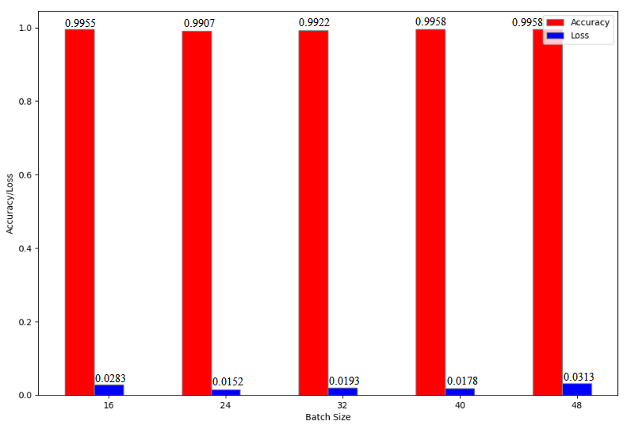

**Dataset Split Ratio**

***Average Time per Epoch***

* 90-5-5: 241.20 s
* 80-10-10: 135.40 s
* 70-15-15: 115.80 s
* 60-20-20: 89.80 s
* 50-25-25: 79.80 s

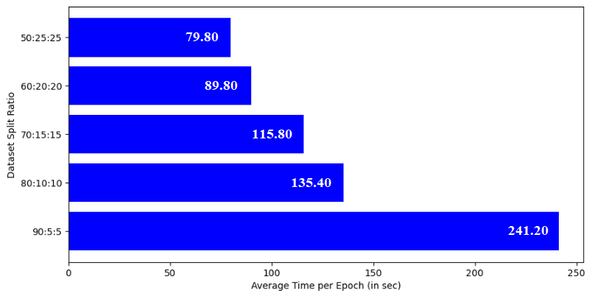

***Precision, Recall, f1 Score*** *(0: Early Blight, 1: Late Blight, 2: Healthy)*

|  |  |  |  |  |  |  |  |  |  |  |  |  |
| --- | --- | --- | --- | --- | --- | --- | --- | --- | --- | --- | --- | --- |
| **Dataset Split Ratio** | **Precision** | | | | **Recall** | | | | **f1 Score** | | | |
| **0** | **1** | **2** | **Weighted Average** | **0** | **1** | **2** | **Weighted Average** | **0** | **1** | **2** | **Weighted Average** |
| 90:5:5 | 1.00 | 1.00 | 1.00 | 1.00 | 1.00 | 1.00 | 1.00 | 1.00 | 1.00 | 1.00 | 1.00 | 1.00 |
| 80:10:10 | 1.00 | 0.99 | 1.00 | 1.00 | 0.99 | 1.00 | 1.00 | 1.00 | 1.00 | 1.00 | 1.00 | 1.00 |
| 70:15:15 | 1.00 | 1.00 | 1.00 | 1.00 | 1.00 | 1.00 | 1.00 | 1.00 | 1.00 | 1.00 | 1.00 | 1.00 |
| 60:20:20 | 1.00 | 0.99 | 1.00 | 1.00 | 1.00 | 1.00 | 0.96 | 1.00 | 1.00 | 1.00 | 0.98 | 1.00 |
| 50:25:25 | 0.99 | 0.98 | 1.00 | 0.99 | 0.99 | 0.99 | 0.94 | 0.99 | 0.99 | 0.99 | 0.97 | 0.99 |

***Accuracy and Loss***

* 90-5-5: 1.0000, 0.0049
* 80-10-10: 0.9961, 0.0159
* 70-15-15: 1.0000, 0.0082
* 60-20-20: 0.9958, 0.0229
* 50-25-25: 0.9871, 0.0315

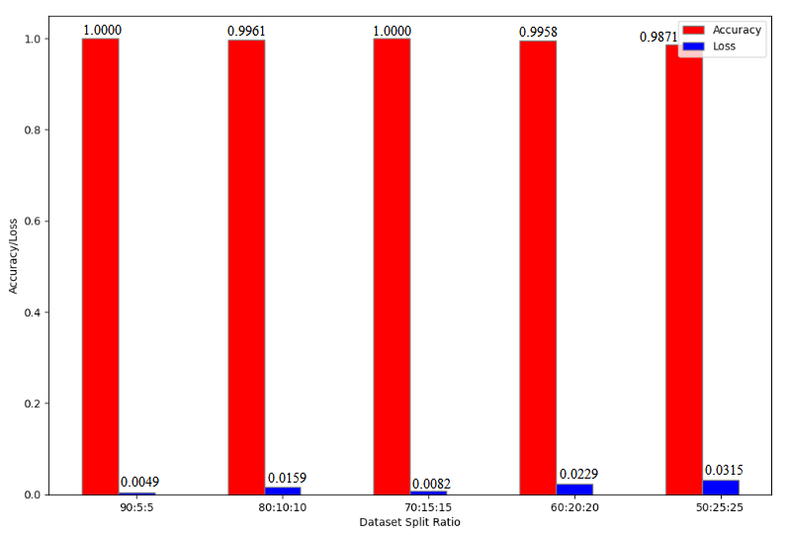

**MODEL 3: VGG16**

**No. of Epochs**

***Average Time per Epoch***

* 2: 574.00 s
* 3: 270.67 s
* 5: 301.80 s
* 7: 306.86 s
* 10: 298.10 s

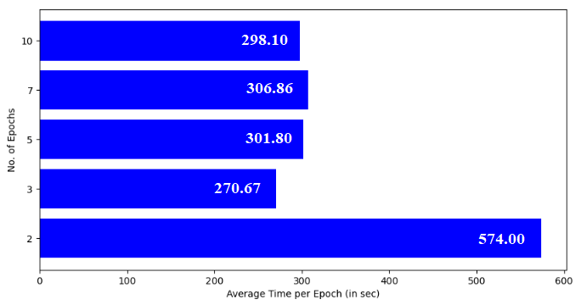

***Precision, Recall, f1 Score*** *(0: Early Blight, 1: Late Blight, 2: Healthy)*

|  |  |  |  |  |  |  |  |  |  |  |  |  |
| --- | --- | --- | --- | --- | --- | --- | --- | --- | --- | --- | --- | --- |
| **No. of Epochs** | **Precision** | | | | **Recall** | | | | **f1 Score** | | | |
| **0** | **1** | **2** | **Weighted Average** | **0** | **1** | **2** | **Weighted Average** | **0** | **1** | **2** | **Weighted Average** |
| 2 | 1.00 | 0.96 | 1.00 | 0.98 | 1.00 | 1.00 | 0.78 | 0.98 | 1.00 | 0.98 | 0.88 | 0.98 |
| 3 | 1.00 | 0.98 | 1.00 | 0.99 | 1.00 | 1.00 | 0.88 | 0.99 | 1.00 | 0.99 | 0.93 | 0.99 |
| 5 | 0.98 | 1.00 | 1.00 | 0.99 | 1.00 | 0.98 | 1.00 | 0.99 | 0.99 | 0.99 | 1.00 | 0.99 |
| 7 | 1.00 | 0.98 | 1.00 | 0.99 | 0.99 | 1.00 | 0.89 | 0.99 | 1.00 | 0.99 | 0.94 | 0.99 |
| 10 | 1.00 | 0.99 | 1.00 | 1.00 | 0.99 | 1.00 | 1.00 | 1.00 | 1.00 | 1.00 | 1.00 | 1.00 |

***Accuracy and Loss***

* 2: 0.9805, 0.1066
* 3: 0.9883, 0.0604
* 5: 0.9922, 0.1107
* 7: 0.9883, 0.1656
* 10: 0.9961, 0.0866

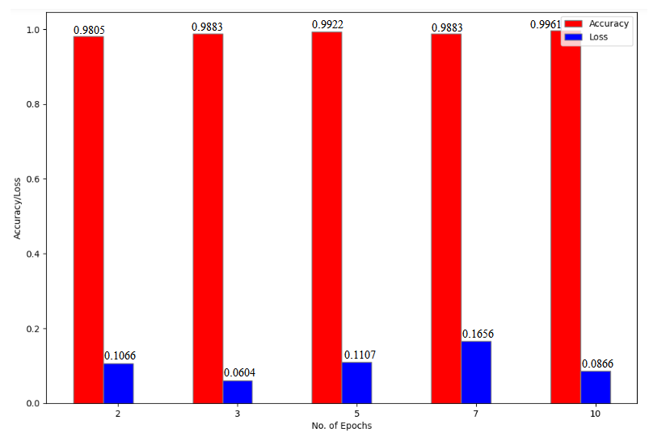

**Batch Size**

***Average Time per Epoch***

* 16: 297.00 s
* 24: 284.80 s
* 32: 286.40 s
* 40: 283.00 s
* 48: 279.80 s

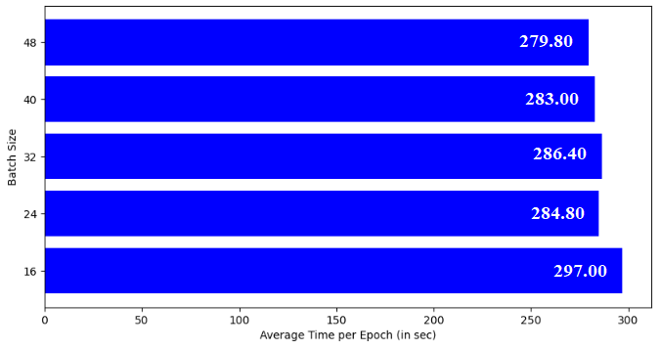

***Precision, Recall, f1 Score*** *(0: Early Blight, 1: Late Blight, 2: Healthy)*

|  |  |  |  |  |  |  |  |  |  |  |  |  |
| --- | --- | --- | --- | --- | --- | --- | --- | --- | --- | --- | --- | --- |
| **Batch Size** | **Precision** | | | | **Recall** | | | | **f1 Score** | | | |
| **0** | **1** | **2** | **Weighted Average** | **0** | **1** | **2** | **Weighted Average** | **0** | **1** | **2** | **Weighted Average** |
| 16 | 1.00 | 0.97 | 1.00 | 0.99 | 0.98 | 1.00 | 0.94 | 0.99 | 0.99 | 0.99 | 0.97 | 0.99 |
| 24 | 1.00 | 1.00 | 1.00 | 1.00 | 1.00 | 1.00 | 1.00 | 1.00 | 1.00 | 1.00 | 1.00 | 1.00 |
| 32 | 1.00 | 1.00 | 1.00 | 1.00 | 1.00 | 1.00 | 1.00 | 1.00 | 1.00 | 1.00 | 1.00 | 1.00 |
| 40 | 0.99 | 1.00 | 0.89 | 0.98 | 1.00 | 0.96 | 1.00 | 0.98 | 1.00 | 0.98 | 0.94 | 0.98 |
| 48 | 1.00 | 0.99 | 1.00 | 1.00 | 0.99 | 1.00 | 1.00 | 1.00 | 1.00 | 1.00 | 1.00 | 1.00 |

***Accuracy and Loss***

* 16: 0.9866, 0.2970
* 24: 1.0000, 0.0019
* 32: 1.0000, 0.0004
* 40: 0.9833, 0.0855
* 48: 0.9958, 0.0139

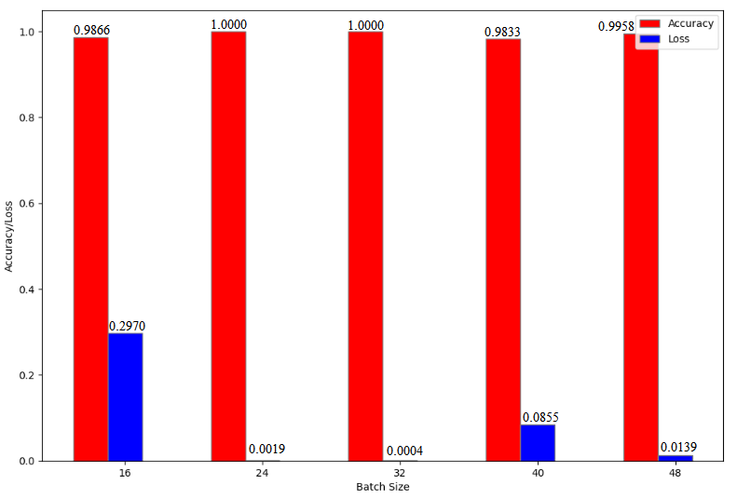

**Dataset Split Ratio**

***Average Time per Epoch***

* 90-5-5: 302.20 s
* 80-10-10: 288.00 s
* 70-15-15: 274.20 s
* 60-20-20: 312.40 s
* 50-25-25: 239.40 s

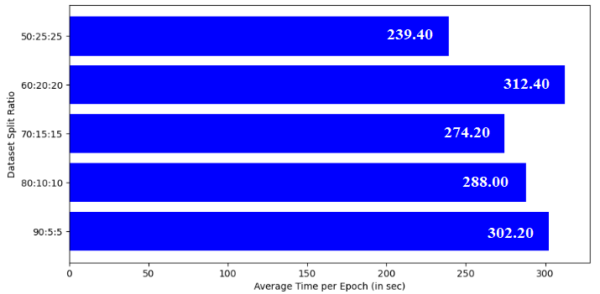

***Precision, Recall, f1 Score*** *(0: Early Blight, 1: Late Blight, 2: Healthy)*

|  |  |  |  |  |  |  |  |  |  |  |  |  |
| --- | --- | --- | --- | --- | --- | --- | --- | --- | --- | --- | --- | --- |
| **Dataset Split Ratio** | **Precision** | | | | **Recall** | | | | **f1 Score** | | | |
| **0** | **1** | **2** | **Weighted Average** | **0** | **1** | **2** | **Weighted Average** | **0** | **1** | **2** | **Weighted Average** |
| 90:5:5 | 1.00 | 1.00 | 1.00 | 1.00 | 1.00 | 1.00 | 1.00 | 1.00 | 1.00 | 1.00 | 1.00 | 1.00 |
| 80:10:10 | 1.00 | 0.99 | 1.00 | 1.00 | 1.00 | 1.00 | 0.96 | 1.00 | 1.00 | 1.00 | 0.98 | 1.00 |
| 70:15:15 | 0.99 | 0.99 | 1.00 | 0.99 | 0.99 | 0.99 | 1.00 | 0.99 | 0.99 | 0.99 | 1.00 | 0.99 |
| 60:20:20 | 0.99 | 0.99 | 1.00 | 0.99 | 1.00 | 0.99 | 0.96 | 0.99 | 1.00 | 0.99 | 0.98 | 0.99 |
| 50:25:25 | 0.98 | 0.98 | 0.94 | 0.98 | 1.00 | 0.98 | 0.89 | 0.98 | 0.99 | 0.98 | 0.92 | 0.98 |

***Accuracy and Loss***

* 90-5-5: 1.0000, 0.0023
* 80-10-10: 0.9961, 0.1033
* 70-15-15: 0.9915, 0.0105
* 60-20-20: 0.9917, 0.0561
* 50-25-25: 0.9798, 0.2934

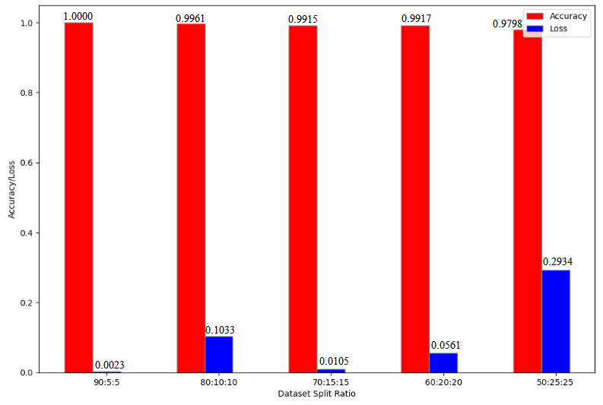

**MODEL 4: VGG19**

**No. of Epochs**

***Average Time per Epoch***

* 2: 319.50 s
* 3: 383.33 s
* 4: 349.00 s
* 5: 350.80 s
* 6: 350.50 s

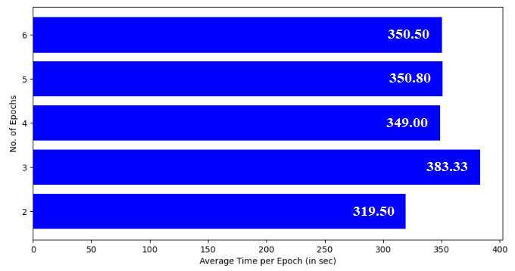

***Precision, Recall, f1 Score*** *(0: Early Blight, 1: Late Blight, 2: Healthy)*

|  |  |  |  |  |  |  |  |  |  |  |  |  |
| --- | --- | --- | --- | --- | --- | --- | --- | --- | --- | --- | --- | --- |
| **No. of Epochs** | **Precision** | | | | **Recall** | | | | **f1 Score** | | | |
| **0** | **1** | **2** | **Weighted Average** | **0** | **1** | **2** | **Weighted Average** | **0** | **1** | **2** | **Weighted Average** |
| 2 | 0.99 | 0.99 | 1.00 | 0.99 | 1.00 | 0.99 | 0.95 | 0.99 | 1.00 | 0.99 | 0.98 | 0.99 |
| 3 | 0.98 | 0.95 | 1.00 | 0.97 | 1.00 | 0.97 | 0.62 | 0.96 | 0.99 | 0.96 | 0.77 | 0.96 |
| 4 | 1.00 | 0.98 | 1.00 | 0.99 | 0.99 | 1.00 | 0.93 | 0.99 | 1.00 | 0.99 | 0.96 | 0.99 |
| 5 | 1.00 | 0.98 | 1.00 | 0.99 | 0.99 | 1.00 | 0.95 | 0.99 | 1.00 | 0.99 | 0.97 | 0.99 |
| 6 | 1.00 | 0.98 | 1.00 | 0.99 | 1.00 | 1.00 | 0.89 | 0.99 | 1.00 | 0.99 | 0.94 | 0.99 |

***Accuracy and Loss***

* 2: 0.9922, 0.0926
* 3: 0.9648, 0.2140
* 4: 0.9922, 0.0279
* 5: 0.9922, 0.0221
* 6: 0.9922, 0.1341

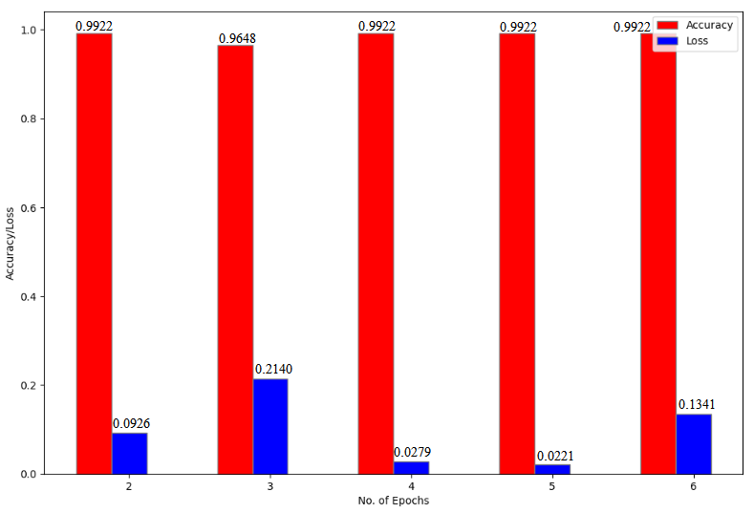

**Batch Size**

***Average Time per Epoch***

* 16: 317.50 s
* 24: 349.50 s
* 32: 318.50 s
* 40: 314.00 s
* 48: 315.50 s

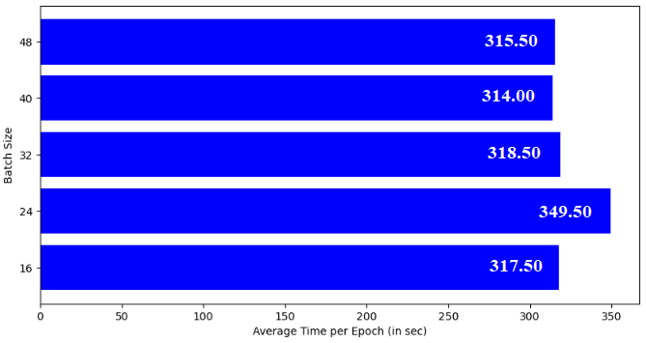

***Precision, Recall, f1 Score*** *(0: Early Blight, 1: Late Blight, 2: Healthy)*

|  |  |  |  |  |  |  |  |  |  |  |  |  |
| --- | --- | --- | --- | --- | --- | --- | --- | --- | --- | --- | --- | --- |
| **Batch Size** | **Precision** | | | | **Recall** | | | | **f1 Score** | | | |
| **0** | **1** | **2** | **Weighted Average** | **0** | **1** | **2** | **Weighted Average** | **0** | **1** | **2** | **Weighted Average** |
| 16 | 0.99 | 1.00 | 1.00 | 1.00 | 1.00 | 0.99 | 1.00 | 1.00 | 1.00 | 1.00 | 1.00 | 1.00 |
| 24 | 1.00 | 1.00 | 0.89 | 1.00 | 1.00 | 0.99 | 1.00 | 1.00 | 1.00 | 0.99 | 0.94 | 1.00 |
| 32 | 1.00 | 0.99 | 1.00 | 1.00 | 0.99 | 1.00 | 1.00 | 1.00 | 0.99 | 1.00 | 1.00 | 1.00 |
| 40 | 0.97 | 1.00 | 0.83 | 0.97 | 1.00 | 0.92 | 1.00 | 0.97 | 0.98 | 0.96 | 0.90 | 0.97 |
| 48 | 1.00 | 1.00 | 1.00 | 1.00 | 1.00 | 1.00 | 1.00 | 1.00 | 1.00 | 1.00 | 1.00 | 1.00 |

***Accuracy and Loss***

* 16: 0.9955, 0.1907
* 24: 0.9954, 0.0125
* 32: 0.9961, 0.0148
* 40: 0.9667, 0.2710
* 48: 1.0000, 0.0003

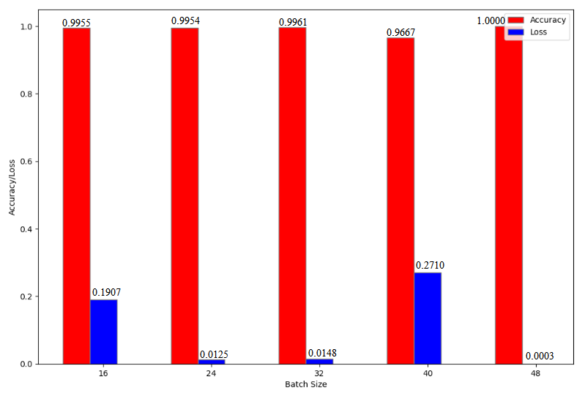

**Dataset Split Ratio**

***Average Time per Epoch***

* 90-5-5: 325.00 s
* 80-10-10: 319.50 s
* 70-15-15: 301.00 s
* 60-20-20: 279.50 s
* 50-25-25: 267.00 s

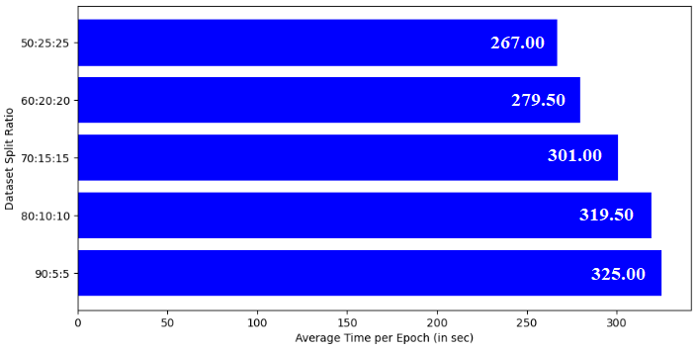

***Precision, Recall, f1 Score*** *(0: Early Blight, 1: Late Blight, 2: Healthy)*

|  |  |  |  |  |  |  |  |  |  |  |  |  |
| --- | --- | --- | --- | --- | --- | --- | --- | --- | --- | --- | --- | --- |
| **Dataset Split Ratio** | **Precision** | | | | **Recall** | | | | **f1 Score** | | | |
| **0** | **1** | **2** | **Weighted Average** | **0** | **1** | **2** | **Weighted Average** | **0** | **1** | **2** | **Weighted Average** |
| 90:5:5 | 1.00 | 0.97 | 0.91 | 0.98 | 0.98 | 0.98 | 0.91 | 0.98 | 0.99 | 0.97 | 0.91 | 0.98 |
| 80:10:10 | 1.00 | 0.99 | 1.00 | 1.00 | 1.00 | 1.00 | 0.94 | 1.00 | 1.00 | 1.00 | 0.97 | 1.00 |
| 70:15:15 | 1.00 | 0.97 | 1.00 | 0.98 | 0.97 | 1.00 | 0.96 | 0.98 | 0.98 | 0.98 | 0.98 | 0.98 |
| 60:20:20 | 0.95 | 0.97 | 0.89 | 0.96 | 0.99 | 0.95 | 0.80 | 0.96 | 0.97 | 0.96 | 0.84 | 0.96 |
| 50:25:25 | 0.98 | 0.97 | 1.00 | 0.98 | 0.98 | 0.98 | 0.88 | 0.98 | 0.98 | 0.97 | 0.94 | 0.98 |

***Accuracy and Loss***

* 90-5-5: 0.9766, 0.1172
* 80-10-10: 0.9961, 0.0187
* 70-15-15: 0.9830, 0.2495
* 60-20-20: 0.9563, 0.1664
* 50-25-25: 0.9761, 0.1463

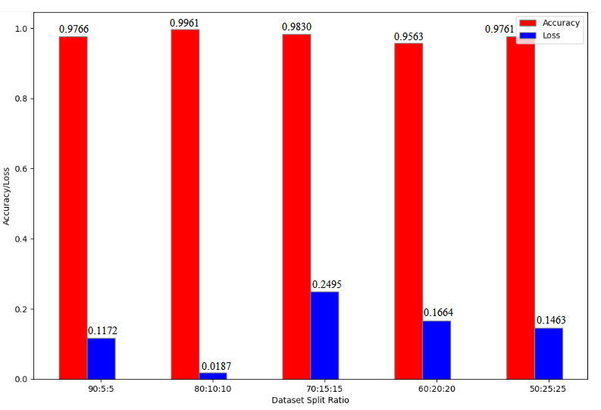

**MODEL 5: InceptionV3**

**No. of Epochs**

***Average Time per Epoch***

* 10: 60.90 s
* 15: 62.27 s
* 20: 61.50 s
* 25: 62.60 s
* 30: 62.63 s

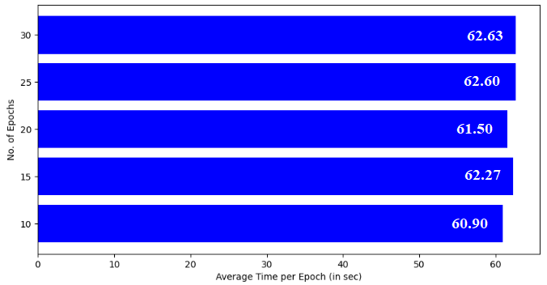

***Precision, Recall, f1 Score*** *(0: Early Blight, 1: Late Blight, 2: Healthy)*

|  |  |  |  |  |  |  |  |  |  |  |  |  |
| --- | --- | --- | --- | --- | --- | --- | --- | --- | --- | --- | --- | --- |
| **No. of Epochs** | **Precision** | | | | **Recall** | | | | **f1 Score** | | | |
| **0** | **1** | **2** | **Weighted Average** | **0** | **1** | **2** | **Weighted Average** | **0** | **1** | **2** | **Weighted Average** |
| 10 | 0.98 | 0.98 | 1.00 | 0.98 | 0.99 | 0.98 | 0.95 | 0.98 | 0.99 | 0.98 | 0.98 | 0.98 |
| 15 | 0.99 | 0.96 | 1.00 | 0.98 | 0.97 | 0.99 | 0.94 | 0.98 | 0.98 | 0.97 | 0.97 | 0.98 |
| 20 | 1.00 | 0.97 | 1.00 | 0.98 | 0.98 | 1.00 | 0.95 | 0.98 | 0.99 | 0.98 | 0.97 | 0.98 |
| 25 | 0.96 | 0.96 | 0.93 | 0.96 | 0.97 | 0.98 | 0.76 | 0.96 | 0.97 | 0.97 | 0.84 | 0.96 |
| 30 | 0.99 | 0.98 | 1.00 | 0.98 | 0.99 | 0.99 | 0.89 | 0.98 | 0.99 | 0.98 | 0.94 | 0.98 |

***Accuracy and Loss***

* 10: 0.9844, 1.0665
* 15: 0.9766, 1.5436
* 20: 0.9844, 1.6718
* 25: 0.9609, 2.7149
* 30: 0.9844, 0.8142

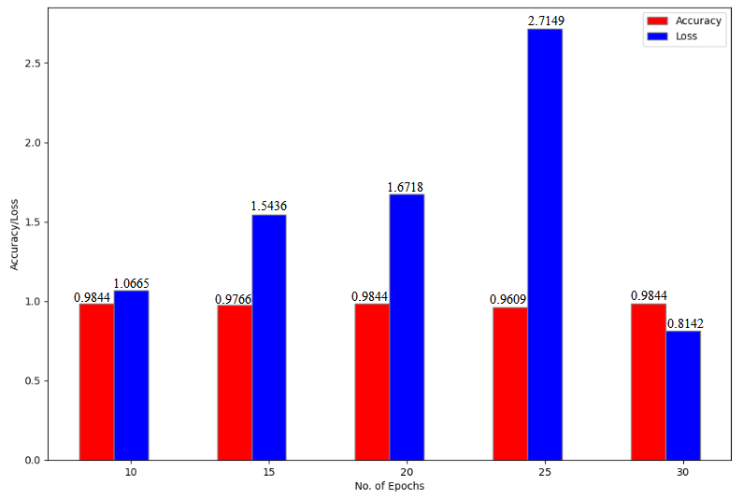

**Batch Size**

***Average Time per Epoch***

* 16: 66.93 s
* 24: 63.40 s
* 32: 62.20 s
* 40: 60.93 s
* 48: 59.20 s

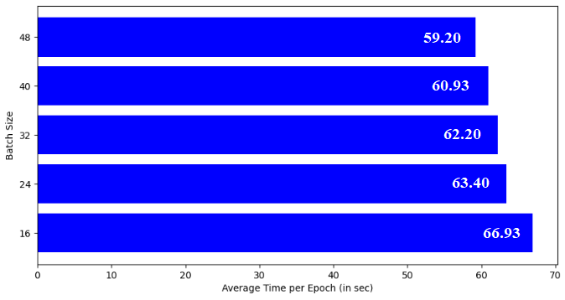

***Precision, Recall, f1 Score*** *(0: Early Blight, 1: Late Blight, 2: Healthy)*

|  |  |  |  |  |  |  |  |  |  |  |  |  |
| --- | --- | --- | --- | --- | --- | --- | --- | --- | --- | --- | --- | --- |
| **Batch Size** | **Precision** | | | | **Recall** | | | | **f1 Score** | | | |
| **0** | **1** | **2** | **Weighted Average** | **0** | **1** | **2** | **Weighted Average** | **0** | **1** | **2** | **Weighted Average** |
| 16 | 0.99 | 0.98 | 1.00 | 0.99 | 0.99 | 0.99 | 0.93 | 0.99 | 0.99 | 0.99 | 0.97 | 0.99 |
| 24 | 0.98 | 0.96 | 1.00 | 0.97 | 0.98 | 0.99 | 0.86 | 0.97 | 0.98 | 0.98 | 0.93 | 0.97 |
| 32 | 0.98 | 0.99 | 0.95 | 0.98 | 0.99 | 0.97 | 1.00 | 0.98 | 0.99 | 0.98 | 0.97 | 0.98 |
| 40 | 1.00 | 0.97 | 0.95 | 0.98 | 1.00 | 0.99 | 0.88 | 0.98 | 1.00 | 0.98 | 0.91 | 0.98 |
| 48 | 0.97 | 0.97 | 0.93 | 0.97 | 0.97 | 0.97 | 0.93 | 0.97 | 0.97 | 0.97 | 0.93 | 0.97 |

***Accuracy and Loss***

* 16: 0.9866, 3.9575
* 24: 0.9722, 2.6249
* 32: 0.9844, 1.7377
* 40: 0.9833, 2.3743
* 48: 0.9708, 1.7254

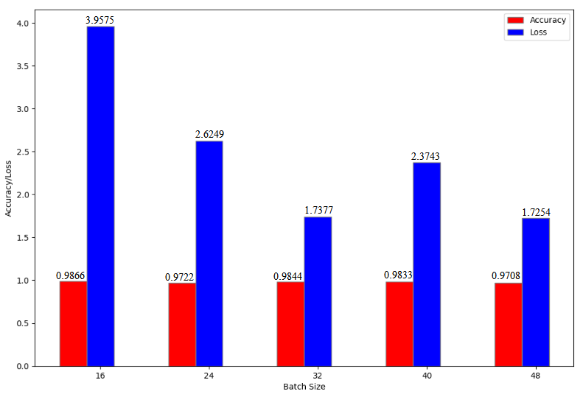

**Dataset Split Ratio**

***Average Time per Epoch***

* 90-5-5: 66.20 s
* 80-10-10: 63.20 s
* 70-15-15: 60.20 s
* 60-20-20: 56.33 s
* 50-25-25: 56.00 s

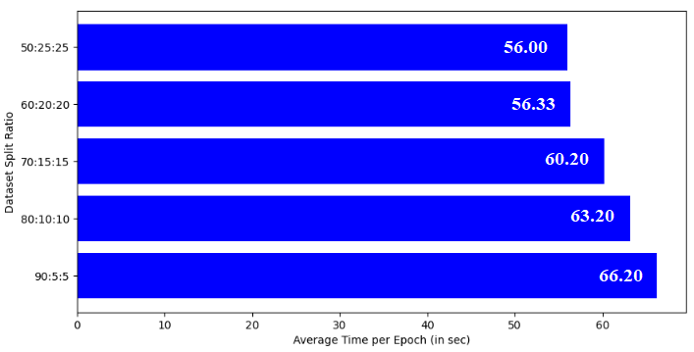

***Precision, Recall, f1 Score*** *(0: Early Blight, 1: Late Blight, 2: Healthy)*

|  |  |  |  |  |  |  |  |  |  |  |  |  |
| --- | --- | --- | --- | --- | --- | --- | --- | --- | --- | --- | --- | --- |
| **Dataset Split Ratio** | **Precision** | | | | **Recall** | | | | **f1 Score** | | | |
| **0** | **1** | **2** | **Weighted Average** | **0** | **1** | **2** | **Weighted Average** | **0** | **1** | **2** | **Weighted Average** |
| 90:5:5 | 1.00 | 1.00 | 1.00 | 1.00 | 1.00 | 1.00 | 1.00 | 1.00 | 1.00 | 1.00 | 1.00 | 1.00 |
| 80:10:10 | 0.98 | 0.94 | 1.00 | 0.97 | 0.97 | 0.99 | 0.82 | 0.96 | 0.98 | 0.96 | 0.90 | 0.96 |
| 70:15:15 | 0.94 | 0.99 | 0.88 | 0.96 | 0.99 | 0.92 | 0.93 | 0.95 | 0.96 | 0.95 | 0.90 | 0.95 |
| 60:20:20 | 0.96 | 0.92 | 0.93 | 0.94 | 0.95 | 0.95 | 0.76 | 0.94 | 0.95 | 0.94 | 0.84 | 0.94 |
| 50:25:25 | 0.96 | 0.88 | 0.85 | 0.92 | 0.93 | 0.95 | 0.64 | 0.92 | 0.94 | 0.91 | 0.73 | 0.92 |

***Accuracy and Loss***

* 90-5-5: 1.0000, 0.0000
* 80-10-10: 0.9648, 2.9319
* 70-15-15: 0.9545, 2.4984
* 60-20-20: 0.9396, 4.0944
* 50-25-25: 0.9173, 5.7160

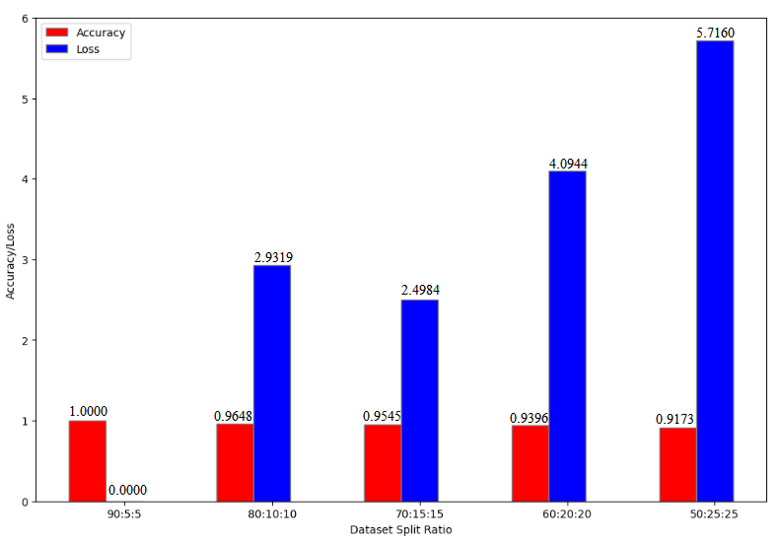

**MODEL 6: AlexNet**

**No. of Epochs**

***Average Time per Epoch***

* 20: 77.15 s
* 25: 80.80 s
* 30: 75.67 s
* 35: 77.14 s
* 40: 75.70 s

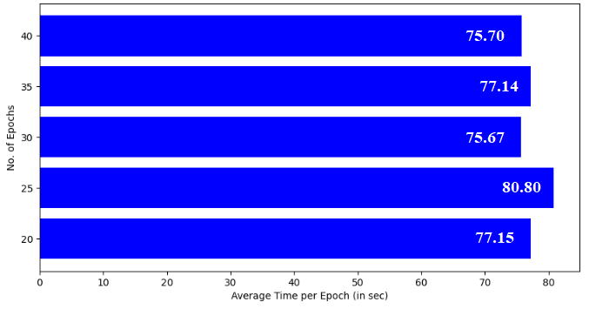

***Precision, Recall, f1 Score*** *(0: Early Blight, 1: Late Blight, 2: Healthy)*

|  |  |  |  |  |  |  |  |  |  |  |  |  |
| --- | --- | --- | --- | --- | --- | --- | --- | --- | --- | --- | --- | --- |
| **No. of Epochs** | **Precision** | | | | **Recall** | | | | **f1 Score** | | | |
| **0** | **1** | **2** | **Weighted Average** | **0** | **1** | **2** | **Weighted Average** | **0** | **1** | **2** | **Weighted Average** |
| 20 | 1.00 | 0.86 | 1.00 | 0.94 | 0.90 | 1.00 | 0.78 | 0.93 | 0.95 | 0.93 | 0.88 | 0.93 |
| 25 | 1.00 | 0.98 | 1.00 | 0.99 | 0.98 | 1.00 | 1.00 | 0.99 | 0.99 | 0.99 | 1.00 | 0.99 |
| 30 | 1.00 | 0.97 | 1.00 | 0.98 | 1.00 | 1.00 | 0.82 | 0.98 | 1.00 | 0.98 | 0.90 | 0.98 |
| 35 | 1.00 | 1.00 | 0.94 | 1.00 | 1.00 | 0.99 | 1.00 | 1.00 | 1.00 | 1.00 | 0.97 | 1.00 |
| 40 | 0.99 | 0.98 | 1.00 | 0.99 | 1.00 | 0.99 | 0.88 | 0.99 | 1.00 | 0.99 | 0.93 | 0.99 |

***Accuracy and Loss***

* 20: 0.9336, 0.2237
* 25: 0.9922, 0.0367
* 30: 0.9844, 0.0306
* 35: 0.9961, 0.0167
* 40: 0.9883, 0.0812

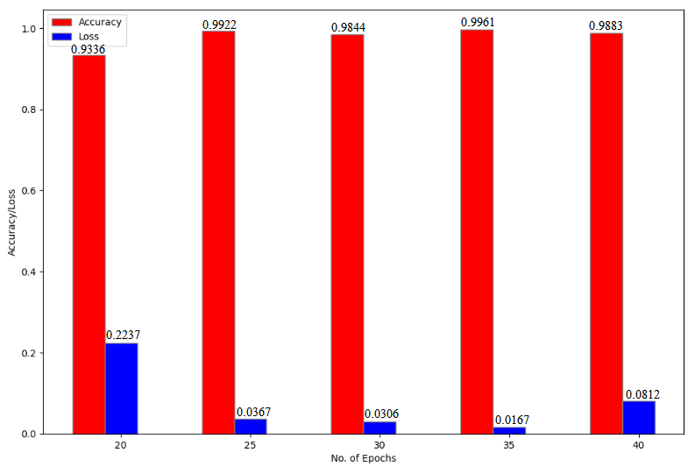

**Batch Size**

***Average Time per Epoch***

* 16: 86.40 s
* 24: 79.05 s
* 32: 73.20 s
* 40: 69.85 s
* 48: 69.55 s

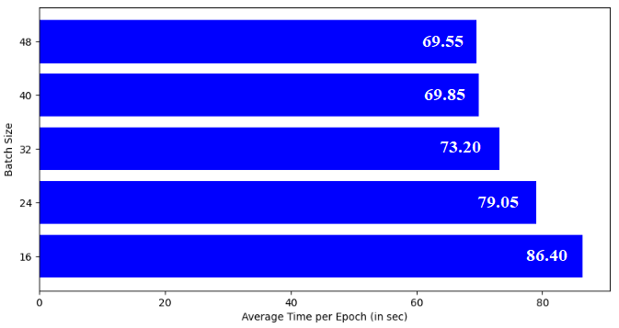

***Precision, Recall, f1 Score*** *(0: Early Blight, 1: Late Blight, 2: Healthy)*

|  |  |  |  |  |  |  |  |  |  |  |  |  |
| --- | --- | --- | --- | --- | --- | --- | --- | --- | --- | --- | --- | --- |
| **Batch Size** | **Precision** | | | | **Recall** | | | | **f1 Score** | | | |
| **0** | **1** | **2** | **Weighted Average** | **0** | **1** | **2** | **Weighted Average** | **0** | **1** | **2** | **Weighted Average** |
| 16 | 0.99 | 0.97 | 0.82 | 0.97 | 0.98 | 0.97 | 0.93 | 0.97 | 0.98 | 0.97 | 0.87 | 0.97 |
| 24 | 0.99 | 0.91 | 1.00 | 0.96 | 0.95 | 0.99 | 0.78 | 0.95 | 0.97 | 0.95 | 0.88 | 0.95 |
| 32 | 0.99 | 0.91 | 1.00 | 0.96 | 0.96 | 1.00 | 0.73 | 0.95 | 0.97 | 0.95 | 0.84 | 0.95 |
| 40 | 0.97 | 1.00 | 0.85 | 0.97 | 1.00 | 0.93 | 1.00 | 0.97 | 0.99 | 0.96 | 0.92 | 0.97 |
| 48 | 1.00 | 0.72 | 1.00 | 0.89 | 0.84 | 1.00 | 0.14 | 0.84 | 0.91 | 0.84 | 0.24 | 0.82 |

***Accuracy and Loss***

* 16: 0.9688, 0.0982
* 24: 0.9537, 0.1140
* 32: 0.9531, 0.1099
* 40: 0.9708, 0.0625
* 48: 0.8417, 0.4727

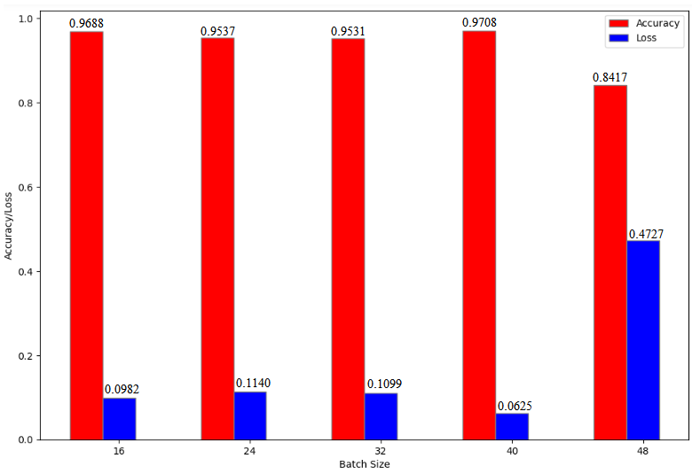

**Dataset Split Ratio**

***Average Time per Epoch***

* 90-5-5: 81.80 s
* 80-10-10: 72.75 s
* 70-15-15: 64.30 s
* 60-20-20: 56.70 s
* 50-25-25: 47.15 s

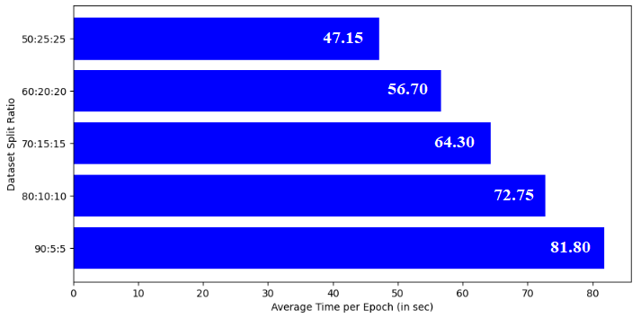

***Precision, Recall, f1 Score*** *(0: Early Blight, 1: Late Blight, 2: Healthy)*

|  |  |  |  |  |  |  |  |  |  |  |  |  |
| --- | --- | --- | --- | --- | --- | --- | --- | --- | --- | --- | --- | --- |
| **Dataset Split Ratio** | **Precision** | | | | **Recall** | | | | **f1 Score** | | | |
| **0** | **1** | **2** | **Weighted Average** | **0** | **1** | **2** | **Weighted Average** | **0** | **1** | **2** | **Weighted Average** |
| 90:5:5 | 0.98 | 0.98 | 1.00 | 0.98 | 0.98 | 0.98 | 1.00 | 0.98 | 0.98 | 0.98 | 1.00 | 0.98 |
| 80:10:10 | 1.00 | 0.97 | 1.00 | 0.98 | 0.99 | 1.00 | 0.82 | 0.98 | 1.00 | 0.98 | 0.90 | 0.98 |
| 70:15:15 | 0.98 | 0.88 | 1.00 | 0.94 | 0.95 | 0.99 | 0.41 | 0.93 | 0.97 | 0.93 | 0.58 | 0.93 |
| 60:20:20 | 0.98 | 0.84 | 1.00 | 0.92 | 0.88 | 1.00 | 0.23 | 0.90 | 0.93 | 0.91 | 0.38 | 0.89 |
| 50:25:25 | 0.99 | 0.77 | 1.00 | 0.89 | 0.74 | 1.00 | 0.75 | 0.86 | 0.85 | 0.87 | 0.86 | 0.86 |

***Accuracy and Loss***

* 90-5-5: 0.9844, 0.0459
* 80-10-10: 0.9844, 0.0335
* 70-15-15: 0.9318, 0.2205
* 60-20-20: 0.9021, 0.3435
* 50-25-25: 0.8585, 0.4169

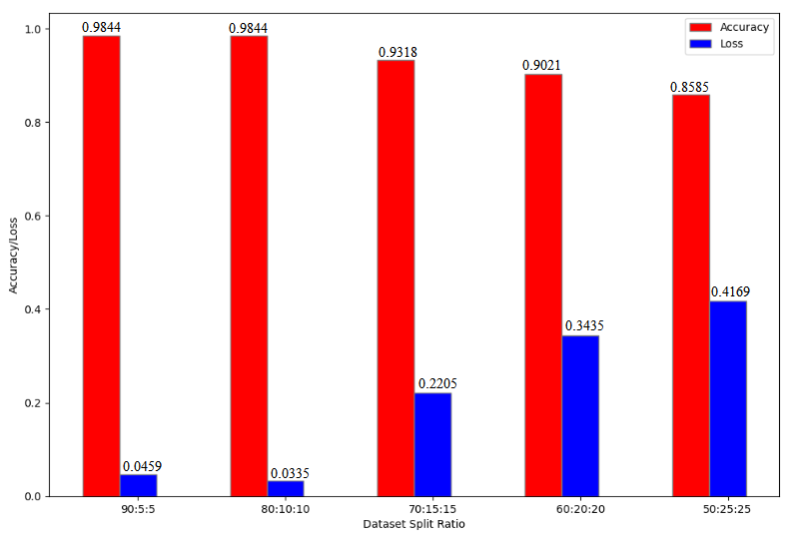

**Dataset 2: Potato**

**BASE MODELS**

**MODEL 1 – CNN**

***No. of Images in Train, Validation and Test Sets***

|  |  |
| --- | --- |
| Total No. of Images: 1500  *(Early Blight: 500, Late Blight: 500, Healthy: 500)* – 80:10:10 Split | |
| **Train** | 1184 |
| **Validation** | 128 |
| **Test** | 188 |

***Model Summary***

* Image Size: 256 x 256
* Batch Size: 32
* No. of Channels: 3
* No. of Epochs: 20

***Graph***

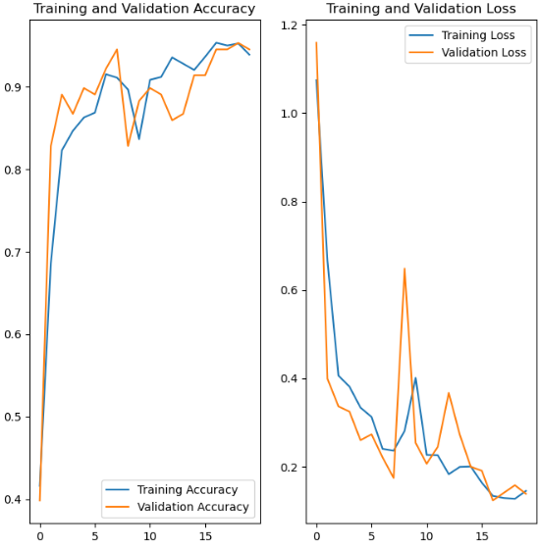

***Confusion Matrix***

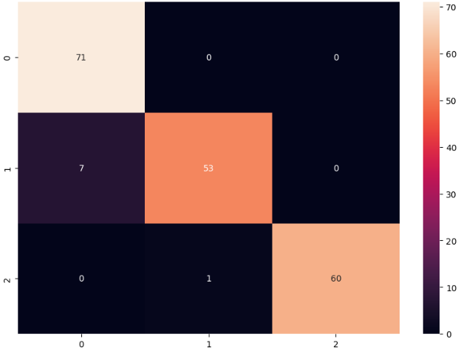

Misclassification Rate: 4.44% (0.00%, 11.67%, 1.64%)

***Predictions***

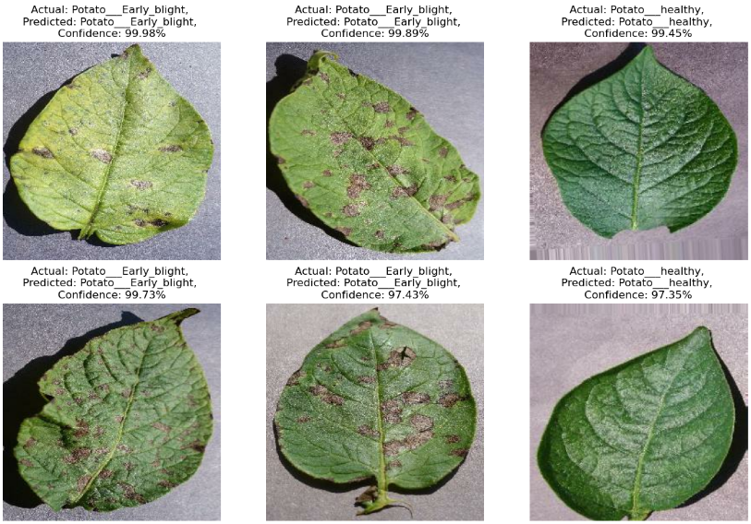

**MODEL 2 – ResNet50**

***No. of Images in Train, Validation and Test Sets***

|  |  |
| --- | --- |
| Total No. of Images: 1500  *(Early Blight: 500, Late Blight: 500, Healthy: 500)* – 80:10:10 Split | |
| **Train** | 1184 |
| **Validation** | 128 |
| **Test** | 188 |

***Model Summary***

* Image Size: 224 x 224
* Batch Size: 32
* No. of Channels: 3
* No. of Epochs: 5

***Graph***

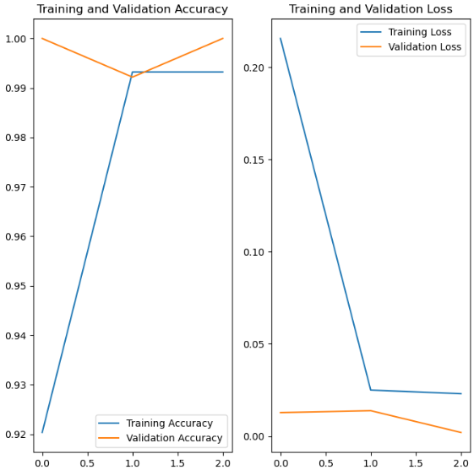

***Confusion Matrix***

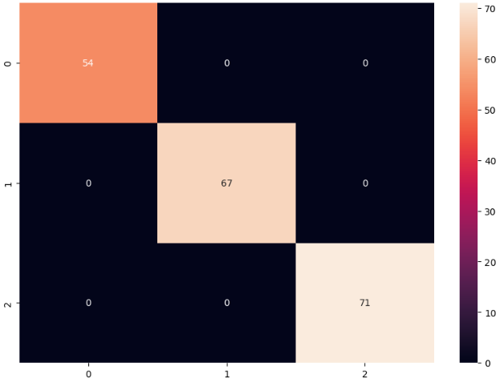

Misclassification Rate: 0.00% (0.00%, 0.00%, 0.00%)

**Predictions**

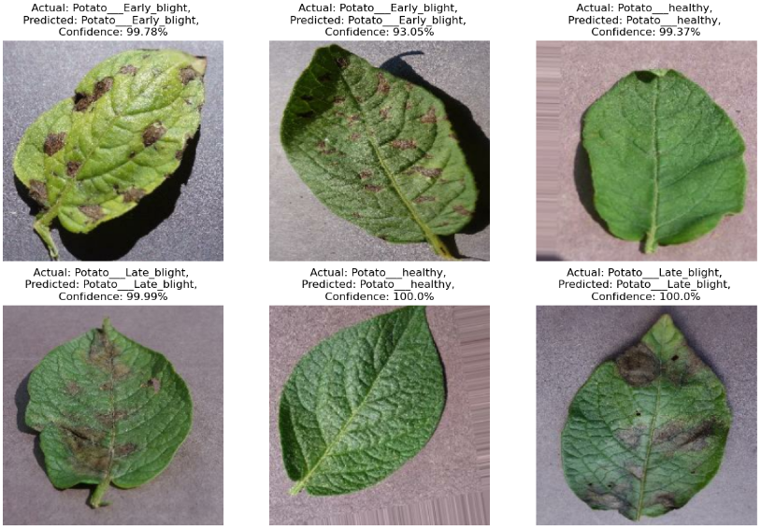

**MODEL 3 – VGG16**

***No. of Images in Train, Validation and Test Sets***

|  |  |
| --- | --- |
| Total No. of Images: 1500  *(Early Blight: 500, Late Blight: 500, Healthy: 500)* – 80:10:10 Split | |
| **Train** | 1184 |
| **Validation** | 128 |
| **Test** | 188 |

***Model Summary***

* Image Size: 224 x 224
* Batch Size: 32
* No. of Channels: 3
* No. of Epochs: 3

***Graph***

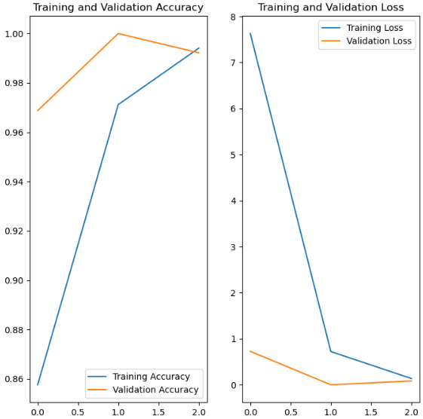

***Confusion Matrix***

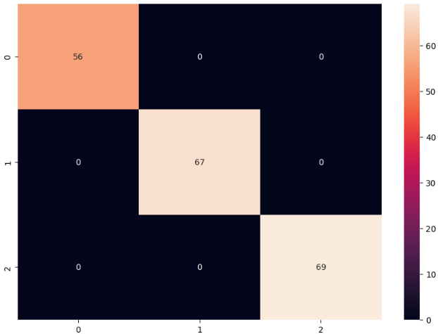

Misclassification Rate: 0.00% (0.00%, 0.00%, 0.00%)

***Predictions***

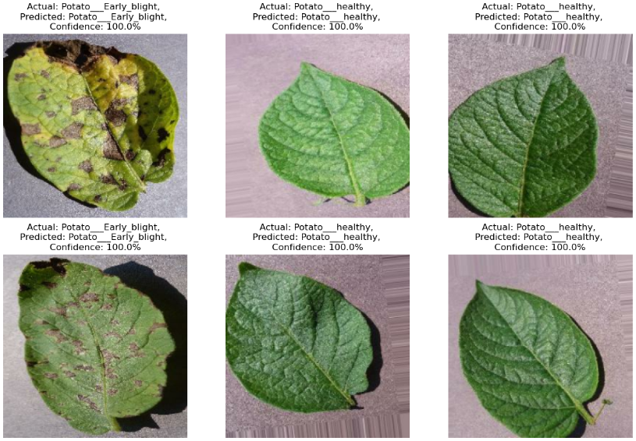

**MODEL 4 – VGG19**

***No. of Images in Train, Validation and Test Sets***

|  |  |
| --- | --- |
| Total No. of Images: 1500  *(Early Blight: 500, Late Blight: 500, Healthy: 500)* – 80:10:10 Split | |
| **Train** | 1184 |
| **Validation** | 128 |
| **Test** | 188 |

***Model Summary***

* Image Size: 224 x 224
* Batch Size: 32
* No. of Channels: 3
* No. of Epochs: 2

***Graph***

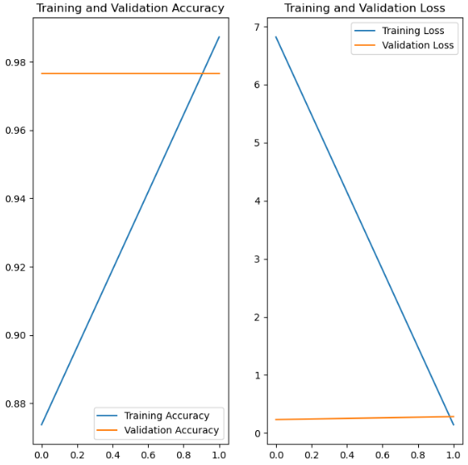

***Confusion Matrix***

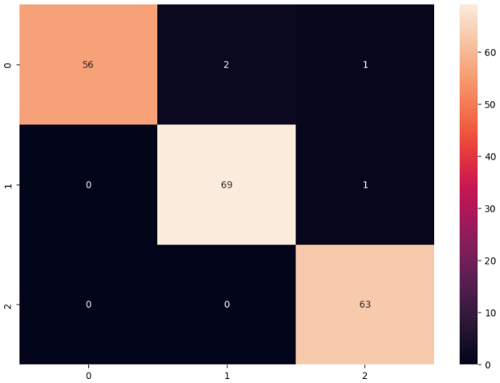

Misclassification Rate: 2.17% (5.08%, 1.43%, 0.00%)

***Predictions***

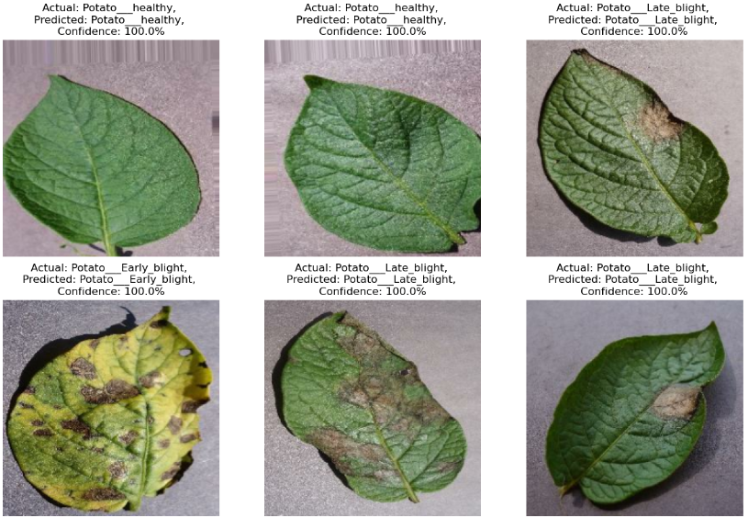

**MODEL 5 – InceptionV3**

***No. of Images in Train, Validation and Test Sets***

|  |  |
| --- | --- |
| Total No. of Images: 1500  *(Early Blight: 500, Late Blight: 500, Healthy: 500)* – 80:10:10 Split | |
| **Train** | 1184 |
| **Validation** | 128 |
| **Test** | 188 |

***Model Summary***

* Image Size: 224 x 224
* Batch Size: 32
* No. of Channels: 3
* No. of Epochs: 15

***Graph***

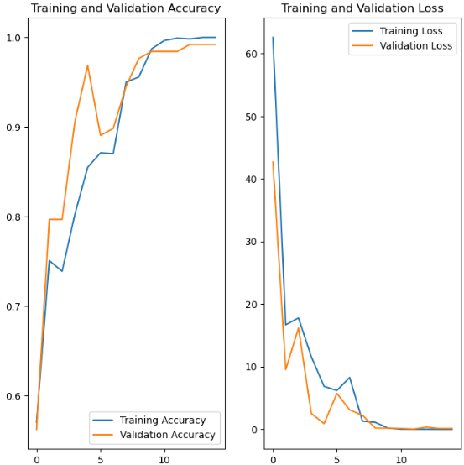

***Confusion Matrix***

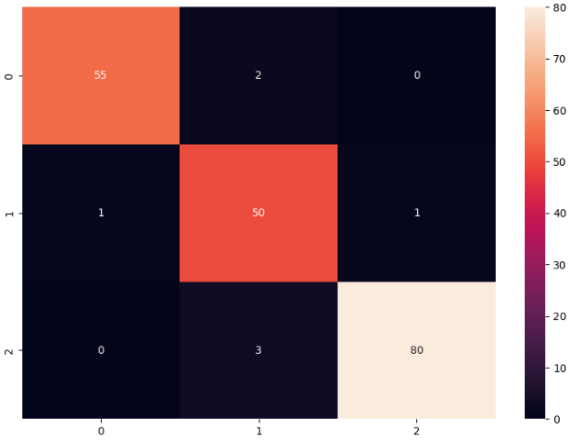

Misclassification Rate: 3.66% (3.51%, 3.85%, 3.61%)

***Predictions***

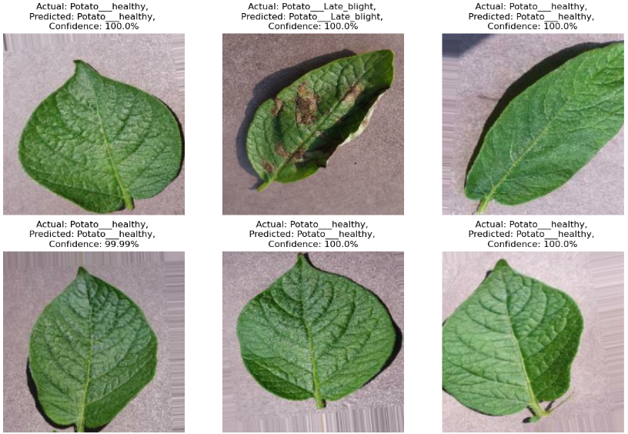

**MODEL 6 – AlexNet**

***No. of Images in Train, Validation and Test Sets***

|  |  |
| --- | --- |
| Total No. of Images: 1500  *(Early Blight: 500, Late Blight: 500, Healthy: 500)* – 80:10:10 Split | |
| **Train** | 1184 |
| **Validation** | 128 |
| **Test** | 188 |

***Model Summary***

* Image Size: 224 x 224
* Batch Size: 32
* No. of Channels: 3
* No. of Epochs: 20

***Graph***

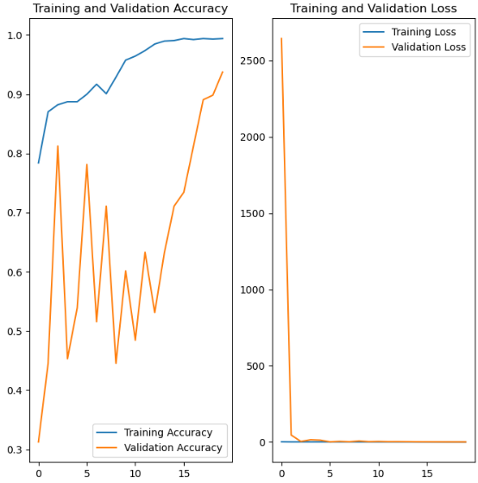

***Confusion Matrix***

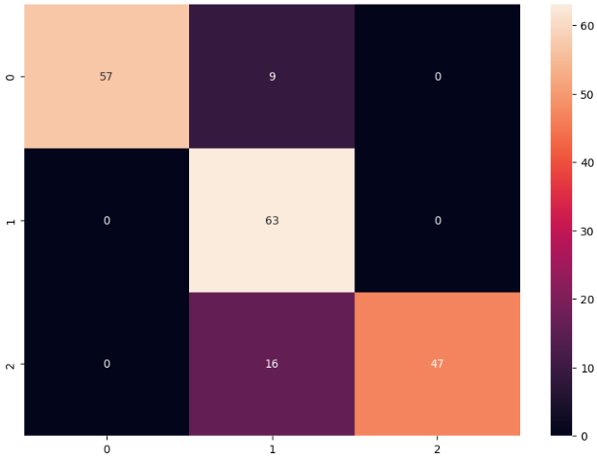

Misclassification Rate: 13.01% (13.64%, 0.00%, 25.40%)

***Predictions***

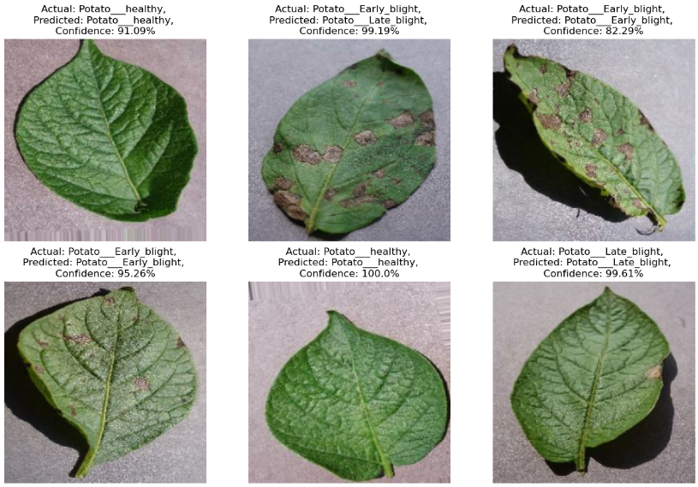

**COMPARISON OF BASE MODELS**

***Average Time per Epoch***

* Model 1 – CNN: 47.55 s
* Model 2 – ResNet50: 70.67 s
* Model 3 – VGG16: 174.00 s
* Model 4 – VGG19: 205.50 s
* Model 5 – InceptionV3: 39.73 s
* Model 6 – AlexNet: 50.30 s

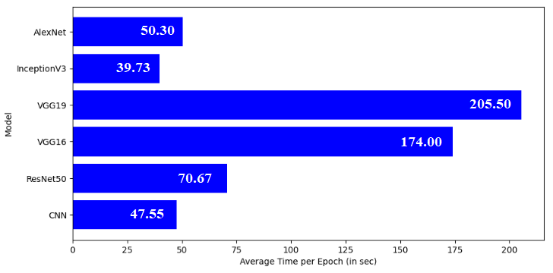

***Precision, Recall, f1 Score*** *(0: Early Blight, 1: Late Blight, 2: Healthy)*

|  |  |  |  |  |  |  |  |  |  |  |  |  |
| --- | --- | --- | --- | --- | --- | --- | --- | --- | --- | --- | --- | --- |
| **Model** | **Precision** | | | | **Recall** | | | | **f1 Score** | | | |
| **0** | **1** | **2** | **Weighted Average** | **0** | **1** | **2** | **Weighted Average** | **0** | **1** | **2** | **Weighted Average** |
| CNN | 0.91 | 0.98 | 1.00 | 0.96 | 1.00 | 0.99 | 0.98 | 0.96 | 0.95 | 0.93 | 0.99 | 0.96 |
| ResNet50 | 1.00 | 1.00 | 1.00 | 1.00 | 1.00 | 1.00 | 1.00 | 1.00 | 1.00 | 1.00 | 1.00 | 1.00 |
| VGG16 | 1.00 | 1.00 | 1.00 | 1.00 | 1.00 | 1.00 | 1.00 | 1.00 | 1.00 | 1.00 | 1.00 | 1.00 |
| VGG19 | 1.00 | 0.97 | 0.97 | 0.98 | 0.95 | 0.99 | 1.00 | 0.98 | 0.97 | 0.98 | 0.98 | 0.98 |
| InceptionV3 | 0.98 | 0.91 | 0.99 | 0.96 | 0.96 | 0.96 | 0.96 | 0.96 | 0.97 | 0.93 | 0.98 | 0.96 |
| AlexNet | 1.00 | 0.72 | 1.00 | 0.91 | 0.86 | 1.00 | 0.75 | 0.87 | 0.93 | 0.83 | 0.85 | 0.87 |

***Accuracy and Loss***

* Model 1 – CNN: 0.9583, 0.1152
* Model 2 – ResNet50: 1.0000, 0.0049
* Model 3 – VGG16: 1.0000, 0.0016
* Model 4 – VGG19: 0.9792, 0.4938
* Model 5 – InceptionV3: 0.9635, 1.8479
* Model 6 – AlexNet: 0.8698, 0.3773

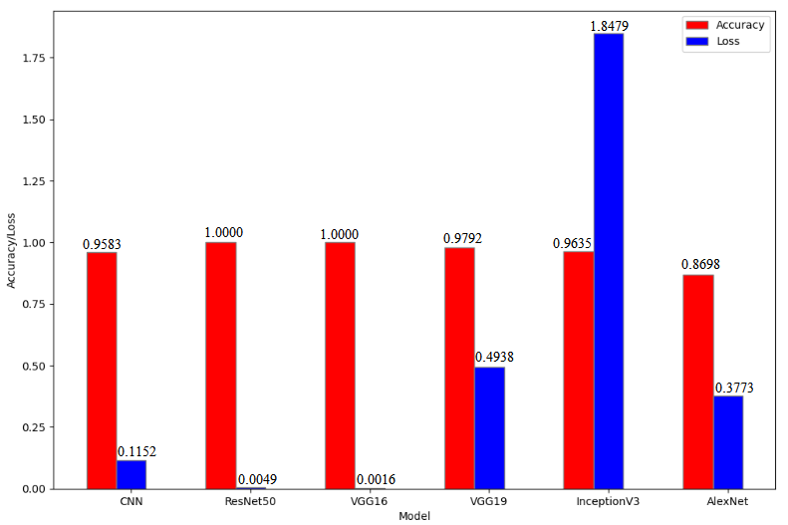

**MODEL COMPARISONS BASED ON NO. OF EPOCHS, BATCH SIZE AND DATASET SPLIT RATION**

**MODEL 1: CNN**

**No. of Epochs**

***Average Time per Epoch***

* 10: 47.55 s
* 20: 46.24 s
* 30: 46.50 s
* 40: 45.17 s
* 50: 45.20 s

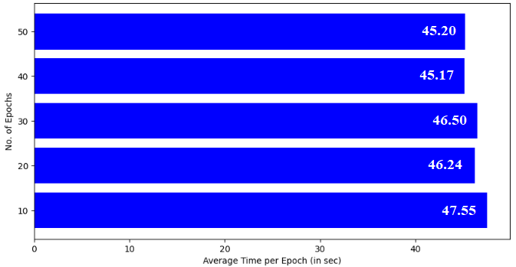

***Precision, Recall, f1 Score*** *(0: Early Blight, 1: Late Blight, 2: Healthy)*

|  |  |  |  |  |  |  |  |  |  |  |  |  |
| --- | --- | --- | --- | --- | --- | --- | --- | --- | --- | --- | --- | --- |
| **No. of Epochs** | **Precision** | | | | **Recall** | | | | **f1 Score** | | | |
| **0** | **1** | **2** | **Weighted Average** | **0** | **1** | **2** | **Weighted Average** | **0** | **1** | **2** | **Weighted Average** |
| 10 | 0.91 | 0.98 | 1.00 | 0.96 | 1.00 | 0.88 | 0.98 | 0.96 | 0.95 | 0.93 | 0.99 | 0.96 |
| 20 | 0.95 | 1.00 | 0.96 | 0.97 | 1.00 | 0.90 | 1.00 | 0.97 | 0.98 | 0.95 | 0.98 | 0.97 |
| 30 | 0.66 | 1.00 | 1.00 | 0.88 | 1.00 | 0.44 | 1.00 | 0.81 | 0.79 | 0.61 | 1.00 | 0.80 |
| 40 | 0.90 | 0.98 | 1.00 | 0.96 | 1.00 | 0.86 | 0.98 | 0.95 | 0.95 | 0.92 | 0.99 | 0.95 |
| 50 | 0.98 | 0.98 | 1.00 | 0.99 | 0.98 | 0.98 | 1.00 | 0.99 | 0.98 | 0.98 | 1.00 | 0.99 |

***Accuracy and Loss***

* 10: 0.9583, 0.1152
* 20: 0.9688, 0.0930
* 30: 0.8125, 0.7763
* 40: 0.9531, 0.1189
* 50: 0.9896, 0.0335

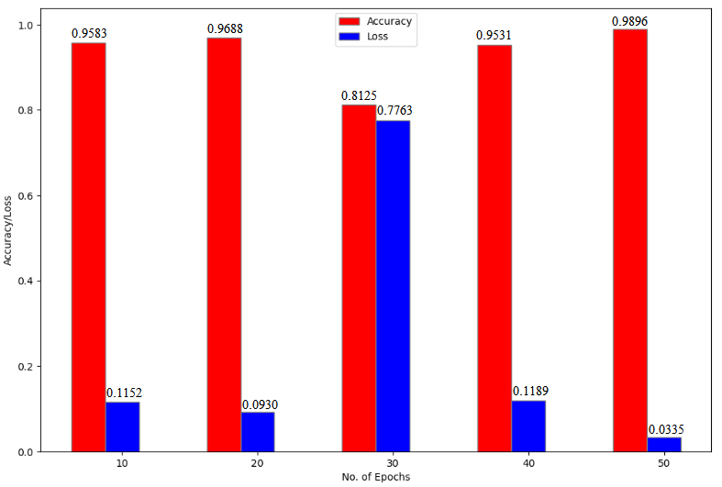

**Batch Size**

***Average Time per Epoch***

* 16: 47.00 s
* 24: 47.50 s
* 32: 45.40 s
* 40: 46.20 s
* 48: 47.25 s

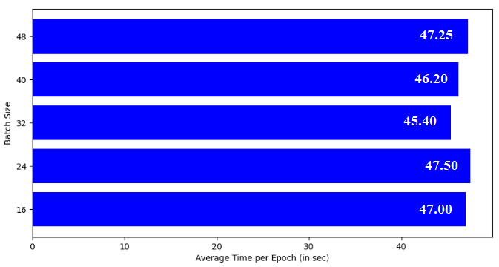

***Precision, Recall, f1 Score*** *(0: Early Blight, 1: Late Blight, 2: Healthy)*

|  |  |  |  |  |  |  |  |  |  |  |  |  |
| --- | --- | --- | --- | --- | --- | --- | --- | --- | --- | --- | --- | --- |
| **Batch Size** | **Precision** | | | | **Recall** | | | | **f1 Score** | | | |
| **0** | **1** | **2** | **Weighted Average** | **0** | **1** | **2** | **Weighted Average** | **0** | **1** | **2** | **Weighted Average** |
| 16 | 0.94 | 1.00 | 1.00 | 0.98 | 1.00 | 0.95 | 1.00 | 0.98 | 0.97 | 0.97 | 1.00 | 0.98 |
| 24 | 0.98 | 0.93 | 1.00 | 0.97 | 1.00 | 0.98 | 0.93 | 0.97 | 0.99 | 0.96 | 0.96 | 0.97 |
| 32 | 0.88 | 0.93 | 0.98 | 0.94 | 1.00 | 0.86 | 0.94 | 0.93 | 0.94 | 0.90 | 0.96 | 0.93 |
| 40 | 0.94 | 1.00 | 0.99 | 0.98 | 1.00 | 0.92 | 1.00 | 0.97 | 0.97 | 0.96 | 0.99 | 0.97 |
| 48 | 0.91 | 1.00 | 0.97 | 0.96 | 1.00 | 0.85 | 1.00 | 0.95 | 0.95 | 0.92 | 0.98 | 0.95 |

***Accuracy and Loss***

* 16: 0.9812, 0.0452
* 24: 0.9702, 0.0965
* 32: 0.9323, 0.1680
* 40: 0.9750, 0.0596
* 48: 0.9531, 0.1211

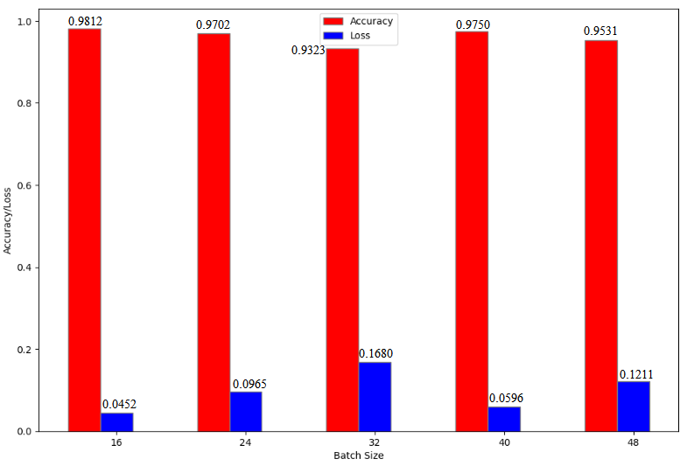

**Dataset Split Ratio**

***Average Time per Epoch***

* 90-5-5: 50.35 s
* 80-10-10: 45.00 s
* 70-15-15: 39.80 s
* 60-20-20: 36.05 s
* 50-25-25: 30.15 s

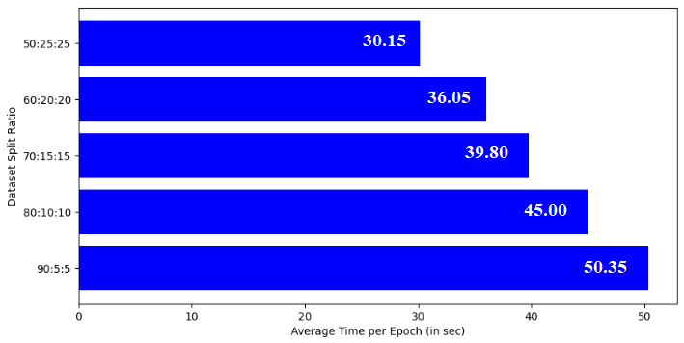

***Precision, Recall, f1 Score*** *(0: Early Blight, 1: Late Blight, 2: Healthy)*

|  |  |  |  |  |  |  |  |  |  |  |  |  |
| --- | --- | --- | --- | --- | --- | --- | --- | --- | --- | --- | --- | --- |
| **Dataset Split Ratio** | **Precision** | | | | **Recall** | | | | **f1 Score** | | | |
| **0** | **1** | **2** | **Weighted Average** | **0** | **1** | **2** | **Weighted Average** | **0** | **1** | **2** | **Weighted Average** |
| 90:5:5 | 0.89 | 0.97 | 1.00 | 0.95 | 1.00 | 0.89 | 0.96 | 0.95 | 0.94 | 0.93 | 0.98 | 0.95 |
| 80:10:10 | 0.96 | 0.98 | 0.98 | 0.97 | 0.99 | 0.94 | 1.00 | 0.97 | 0.97 | 0.96 | 0.99 | 0.97 |
| 70:15:15 | 0.76 | 0.80 | 1.00 | 0.86 | 1.00 | 0.65 | 0.86 | 0.84 | 0.86 | 0.72 | 0.92 | 0.84 |
| 60:20:20 | 0.86 | 1.00 | 0.98 | 0.95 | 1.00 | 0.81 | 1.00 | 0.94 | 0.93 | 0.89 | 0.99 | 0.94 |
| 50:25:25 | 0.92 | 1.00 | 0.98 | 0.97 | 1.00 | 0.89 | 1.00 | 0.96 | 0.96 | 0.94 | 0.99 | 0.96 |

***Accuracy and Loss***

* 90-5-5: 0.9479, 0.1488
* 80-10-10: 0.9740, 0.0835
* 70-15-15: 0.8438, 0.2986
* 60-20-20: 0.9375, 0.1598
* 50-25-25: 0.9636, 0.1043

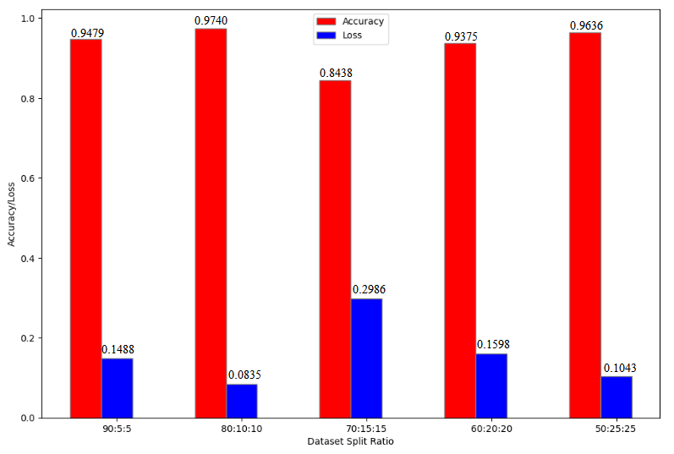

**MODEL 2: ResNet50**

**No. of Epochs**

***Average Time per Epoch***

* 2: 69.00 s
* 3: 70.67 s
* 4: 71.25 s
* 5: 69.20 s
* 6: 70.67 s

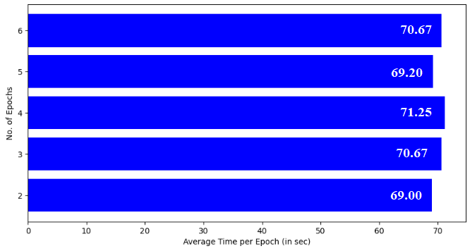

***Precision, Recall, f1 Score*** *(0: Early Blight, 1: Late Blight, 2: Healthy)*

|  |  |  |  |  |  |  |  |  |  |  |  |  |
| --- | --- | --- | --- | --- | --- | --- | --- | --- | --- | --- | --- | --- |
| **No. of Epochs** | **Precision** | | | | **Recall** | | | | **f1 Score** | | | |
| **0** | **1** | **2** | **Weighted Average** | **0** | **1** | **2** | **Weighted Average** | **0** | **1** | **2** | **Weighted Average** |
| 2 | 1.00 | 1.00 | 1.00 | 1.00 | 1.00 | 1.00 | 1.00 | 1.00 | 1.00 | 1.00 | 1.00 | 1.00 |
| 3 | 1.00 | 1.00 | 1.00 | 1.00 | 1.00 | 1.00 | 1.00 | 1.00 | 1.00 | 1.00 | 1.00 | 1.00 |
| 4 | 1.00 | 1.00 | 1.00 | 1.00 | 1.00 | 1.00 | 1.00 | 1.00 | 1.00 | 1.00 | 1.00 | 1.00 |
| 5 | 1.00 | 1.00 | 1.00 | 1.00 | 1.00 | 1.00 | 1.00 | 1.00 | 1.00 | 1.00 | 1.00 | 1.00 |
| 6 | 1.00 | 1.00 | 1.00 | 1.00 | 1.00 | 1.00 | 1.00 | 1.00 | 1.00 | 1.00 | 1.00 | 1.00 |

***Accuracy and Loss***

* 2: 1.0000, 0.0033
* 3: 1.0000, 0.0049
* 4: 1.0000, 0.0029
* 5: 1.0000, 0.0064
* 6: 1.0000, 0.0064

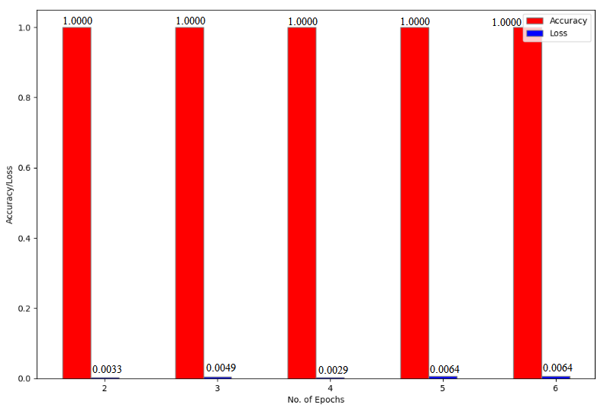

**Batch Size**

***Average Time per Epoch***

* 16: 69.00 s
* 24: 70.00 s
* 32: 73.00 s
* 40: 71.33 s
* 48: 71.67 s

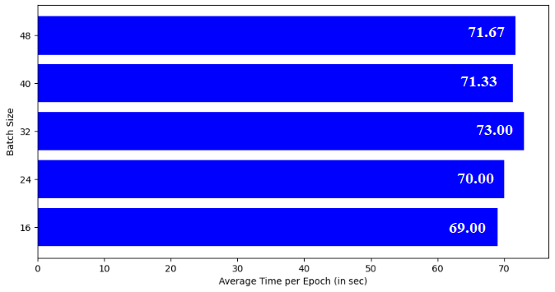

***Precision, Recall, f1 Score*** *(0: Early Blight, 1: Late Blight, 2: Healthy)*

|  |  |  |  |  |  |  |  |  |  |  |  |  |
| --- | --- | --- | --- | --- | --- | --- | --- | --- | --- | --- | --- | --- |
| **Batch Size** | **Precision** | | | | **Recall** | | | | **f1 Score** | | | |
| **0** | **1** | **2** | **Weighted Average** | **0** | **1** | **2** | **Weighted Average** | **0** | **1** | **2** | **Weighted Average** |
| 16 | 1.00 | 0.95 | 1.00 | 0.98 | 0.96 | 1.00 | 0.98 | 0.98 | 0.98 | 0.97 | 0.99 | 0.98 |
| 24 | 1.00 | 1.00 | 1.00 | 1.00 | 1.00 | 1.00 | 1.00 | 1.00 | 1.00 | 1.00 | 1.00 | 1.00 |
| 32 | 1.00 | 1.00 | 1.00 | 1.00 | 1.00 | 1.00 | 1.00 | 1.00 | 1.00 | 1.00 | 1.00 | 1.00 |
| 40 | 1.00 | 1.00 | 1.00 | 1.00 | 1.00 | 1.00 | 1.00 | 1.00 | 1.00 | 1.00 | 1.00 | 1.00 |
| 48 | 1.00 | 0.99 | 1.00 | 0.99 | 0.98 | 1.00 | 1.00 | 0.99 | 0.99 | 0.99 | 1.00 | 0.99 |

***Accuracy and Loss***

* 16: 0.9812, 0.0421
* 24: 1.0000, 0.0056
* 32: 1.0000. 0.0076
* 40: 1.0000, 0.0141
* 48: 0.9948, 0.0179

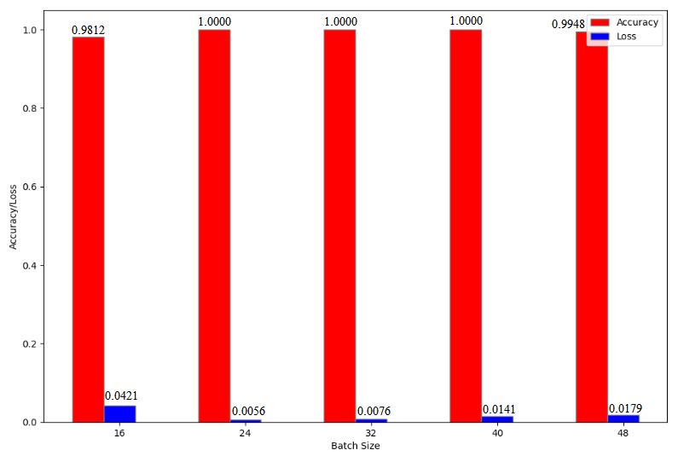

**Dataset Split Ratio**

***Average Time per Epoch***

* 90-5-5: 85.67 s
* 80-10-10: 78.33 s
* 70-15-15: 71.00 s
* 60-20-20: 62.33 s
* 50-25-25: 48.67 s

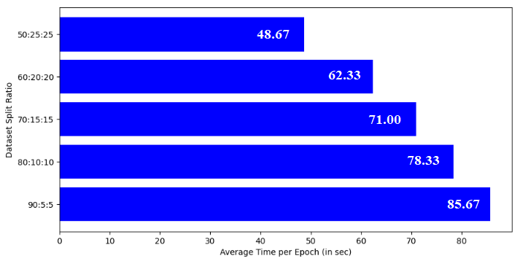

***Precision, Recall, f1 Score*** *(0: Early Blight, 1: Late Blight, 2: Healthy)*

|  |  |  |  |  |  |  |  |  |  |  |  |  |
| --- | --- | --- | --- | --- | --- | --- | --- | --- | --- | --- | --- | --- |
| **Dataset Split Ratio** | **Precision** | | | | **Recall** | | | | **f1 Score** | | | |
| **0** | **1** | **2** | **Weighted Average** | **0** | **1** | **2** | **Weighted Average** | **0** | **1** | **2** | **Weighted Average** |
| 90:5:5 | 1.00 | 0.94 | 1.00 | 0.98 | 0.97 | 1.00 | 0.96 | 0.98 | 0.99 | 0.97 | 0.98 | 0.98 |
| 80:10:10 | 1.00 | 1.00 | 0.95 | 0.98 | 1.00 | 0.93 | 1.00 | 0.98 | 1.00 | 0.96 | 0.97 | 0.98 |
| 70:15:15 | 1.00 | 0.99 | 1.00 | 1.00 | 1.00 | 1.00 | 0.99 | 1.00 | 1.00 | 0.99 | 0.99 | 1.00 |
| 60:20:20 | 1.00 | 1.00 | 0.98 | 0.99 | 1.00 | 0.98 | 1.00 | 0.99 | 1.00 | 0.99 | 0.99 | 0.99 |
| 50:25:25 | 1.00 | 0.96 | 1.00 | 0.99 | 0.98 | 1.00 | 0.98 | 0.99 | 0.99 | 0.98 | 0.99 | 0.99 |

***Accuracy and Loss***

* 90-5-5: 0.9792, 0.0444
* 80-10-10: 0.9792, 0.0427
* 70-15-15: 0.9961, 0.0144
* 60-20-20: 0.9937, 0.0173
* 50-25-25: 0.9854, 0.0417

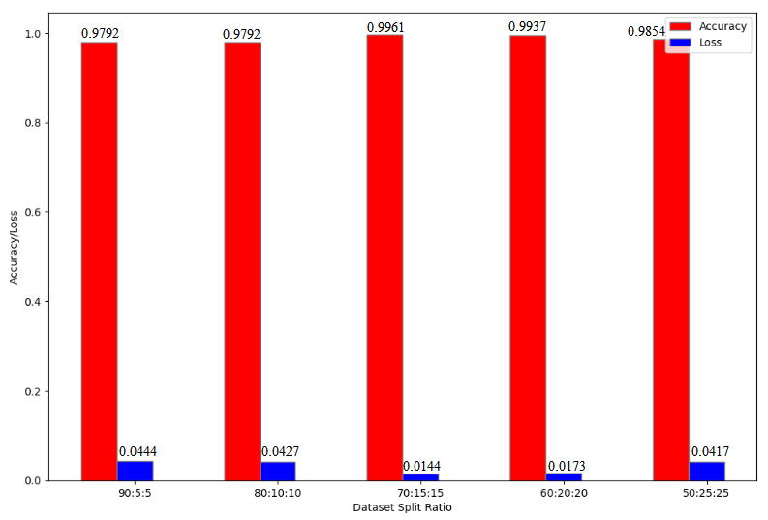

**MODEL 3: VGG16**

**No. of Epochs**

***Average Time per Epoch***

* 2: 169.50 s
* 3: 174.00 s
* 4: 171.50 s
* 5: 178.00 s
* 6: 170.50 s

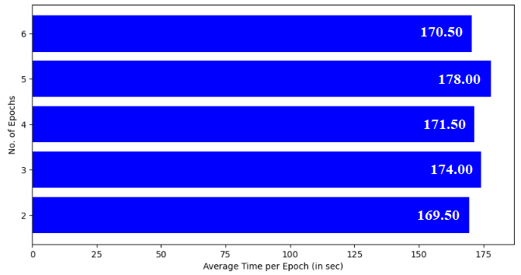

***Precision, Recall, f1 Score*** *(0: Early Blight, 1: Late Blight, 2: Healthy)*

|  |  |  |  |  |  |  |  |  |  |  |  |  |
| --- | --- | --- | --- | --- | --- | --- | --- | --- | --- | --- | --- | --- |
| **No. of Epochs** | **Precision** | | | | **Recall** | | | | **f1 Score** | | | |
| **0** | **1** | **2** | **Weighted Average** | **0** | **1** | **2** | **Weighted Average** | **0** | **1** | **2** | **Weighted Average** |
| 2 | 1.00 | 1.00 | 1.00 | 1.00 | 1.00 | 1.00 | 1.00 | 1.00 | 1.00 | 1.00 | 1.00 | 1.00 |
| 3 | 1.00 | 1.00 | 1.00 | 1.00 | 1.00 | 1.00 | 1.00 | 1.00 | 1.00 | 1.00 | 1.00 | 1.00 |
| 4 | 0.99 | 0.98 | 1.00 | 0.99 | 0.99 | 0.98 | 1.00 | 0.99 | 0.99 | 0.98 | 1.00 | 0.99 |
| 5 | 0.98 | 1.00 | 1.00 | 0.99 | 1.00 | 0.98 | 1.00 | 0.99 | 0.99 | 0.99 | 1.00 | 0.99 |
| 6 | 0.98 | 1.00 | 1.00 | 0.99 | 1.00 | 0.98 | 1.00 | 0.99 | 0.99 | 0.99 | 1.00 | 0.99 |

***Accuracy and Loss***

* 2: 1.0000, 0.0000
* 3: 1.0000, 0.0016
* 4: 0.9896, 0.1364
* 5: 0.9948, 0.0237
* 6: 0.9948, 0.0199

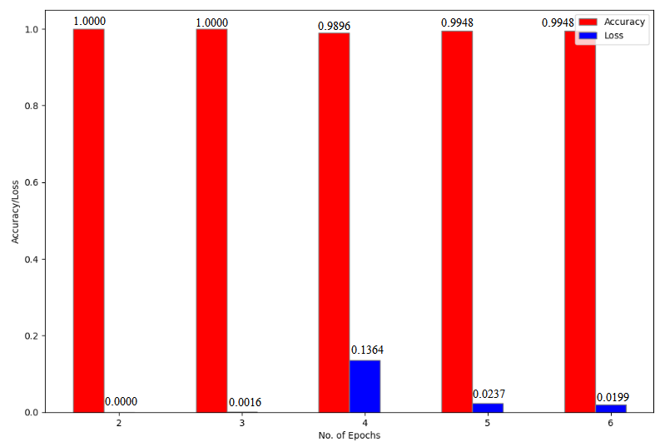

**Batch Size**

***Average Time per Epoch***

* 16: 176.67 s
* 24: 173.00 s
* 32: 170.00 s
* 40: 167.33 s
* 48: 171.67 s

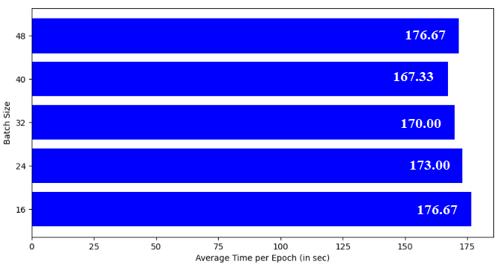

***Precision, Recall, f1 Score*** *(0: Early Blight, 1: Late Blight, 2: Healthy)*

|  |  |  |  |  |  |  |  |  |  |  |  |  |
| --- | --- | --- | --- | --- | --- | --- | --- | --- | --- | --- | --- | --- |
| **Batch Size** | **Precision** | | | | **Recall** | | | | **f1 Score** | | | |
| **0** | **1** | **2** | **Weighted Average** | **0** | **1** | **2** | **Weighted Average** | **0** | **1** | **2** | **Weighted Average** |
| 16 | 1.00 | 1.00 | 1.00 | 1.00 | 1.00 | 1.00 | 1.00 | 1.00 | 1.00 | 1.00 | 1.00 | 1.00 |
| 24 | 1.00 | 1.00 | 1.00 | 1.00 | 1.00 | 1.00 | 1.00 | 1.00 | 1.00 | 1.00 | 1.00 | 1.00 |
| 32 | 1.00 | 1.00 | 1.00 | 1.00 | 1.00 | 1.00 | 1.00 | 1.00 | 1.00 | 1.00 | 1.00 | 1.00 |
| 40 | 1.00 | 1.00 | 1.00 | 1.00 | 1.00 | 1.00 | 1.00 | 1.00 | 1.00 | 1.00 | 1.00 | 1.00 |
| 48 | 1.00 | 1.00 | 1.00 | 1.00 | 1.00 | 1.00 | 1.00 | 1.00 | 1.00 | 1.00 | 1.00 | 1.00 |

***Accuracy and Loss***

* 16: 1.0000, 0.0000
* 24: 1.0000, 0.0000
* 32: 1.0000, 0.0013
* 40: 1.0000, 0.0000
* 48: 1.0000, 0.0035

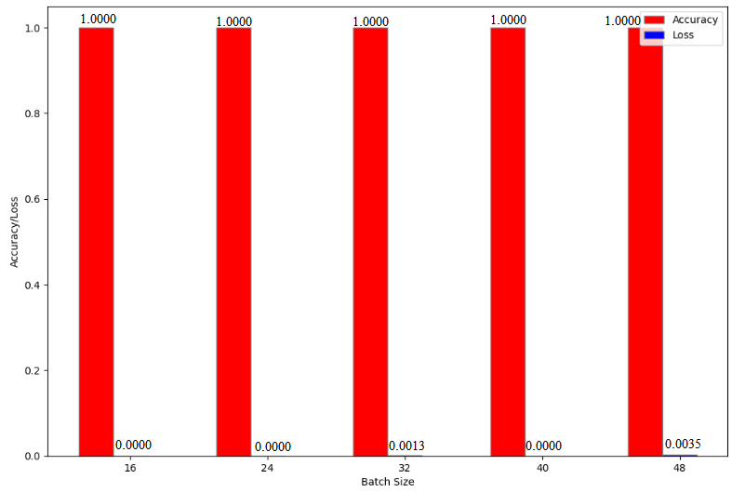

**Dataset Split Ratio**

***Average Time per Epoch***

* 90-5-5: 180.00 s
* 80-10-10: 167.33 s
* 70-15-15: 159.00 s
* 60-20-20: 151.67 s
* 50-25-25: 138.00 s

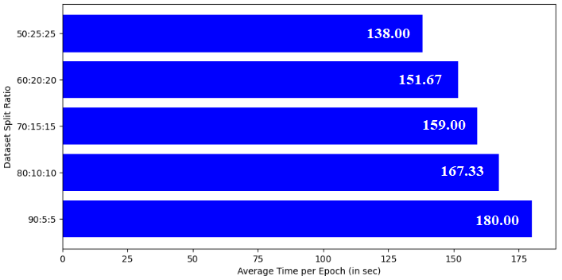

***Precision, Recall, f1 Score*** *(0: Early Blight, 1: Late Blight, 2: Healthy)*

|  |  |  |  |  |  |  |  |  |  |  |  |  |
| --- | --- | --- | --- | --- | --- | --- | --- | --- | --- | --- | --- | --- |
| **Dataset Split Ratio** | **Precision** | | | | **Recall** | | | | **f1 Score** | | | |
| **0** | **1** | **2** | **Weighted Average** | **0** | **1** | **2** | **Weighted Average** | **0** | **1** | **2** | **Weighted Average** |
| 90:5:5 | 1.00 | 1.00 | 1.00 | 1.00 | 1.00 | 1.00 | 1.00 | 1.00 | 1.00 | 1.00 | 1.00 | 1.00 |
| 80:10:10 | 1.00 | 0.97 | 1.00 | 0.99 | 1.00 | 1.00 | 0.97 | 0.99 | 1.00 | 0.99 | 0.99 | 0.99 |
| 70:15:15 | 0.97 | 0.97 | 1.00 | 0.98 | 0.96 | 0.98 | 1.00 | 0.98 | 0.97 | 0.97 | 1.00 | 0.98 |
| 60:20:20 | 0.96 | 0.99 | 0.99 | 0.98 | 1.00 | 0.96 | 0.99 | 0.98 | 0.98 | 0.97 | 0.99 | 0.98 |
| 50:25:25 | 0.96 | 0.99 | 0.97 | 0.97 | 0.98 | 0.93 | 1.00 | 0.97 | 0.97 | 0.96 | 0.98 | 0.97 |

***Accuracy and Loss***

* 90-5-5: 1.0000, 0.0000
* 80-10-10: 0.9896, 0.2427
* 70-15-15: 0.9805, 0.2317
* 60-20-20: 0.9812, 0.1401
* 50-25-25: 0.9709, 0.4901

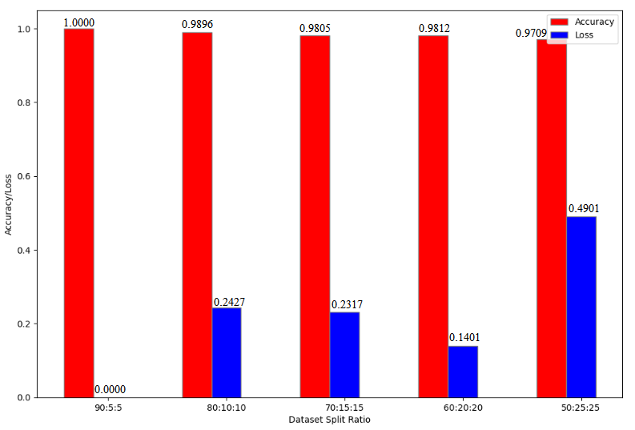

**MODEL 4: VGG19**

**No. of Epochs**

***Average Time per Epoch***

* 2: 205.50 s
* 3: 217.67 s
* 4: 209.50 s
* 5: 210.40 s
* 6: 209.33 s

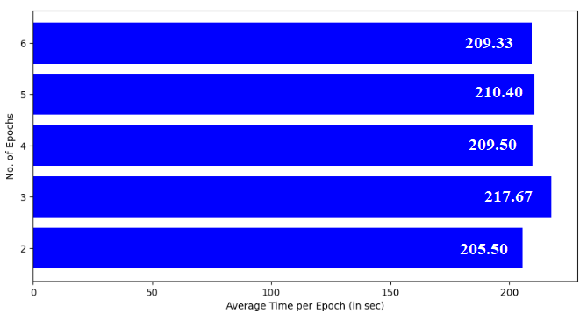

***Precision, Recall, f1 Score*** *(0: Early Blight, 1: Late Blight, 2: Healthy)*

|  |  |  |  |  |  |  |  |  |  |  |  |  |
| --- | --- | --- | --- | --- | --- | --- | --- | --- | --- | --- | --- | --- |
| **No. of Epochs** | **Precision** | | | | **Recall** | | | | **f1 Score** | | | |
| **0** | **1** | **2** | **Weighted Average** | **0** | **1** | **2** | **Weighted Average** | **0** | **1** | **2** | **Weighted Average** |
| 2 | 1.00 | 0.97 | 0.97 | 0.98 | 0.95 | 0.99 | 1.00 | 0.98 | 0.97 | 0.98 | 0.98 | 0.98 |
| 3 | 1.00 | 1.00 | 1.00 | 1.00 | 1.00 | 1.00 | 1.00 | 1.00 | 1.00 | 1.00 | 1.00 | 1.00 |
| 4 | 0.99 | 1.00 | 0.99 | 0.99 | 1.00 | 0.96 | 1.00 | 0.99 | 0.99 | 0.98 | 0.99 | 0.99 |
| 5 | 0.98 | 0.97 | 0.98 | 0.98 | 0.97 | 0.97 | 1.00 | 0.98 | 0.98 | 0.97 | 0.99 | 0.98 |
| 6 | 0.95 | 1.00 | 0.99 | 0.98 | 1.00 | 0.93 | 1.00 | 0.98 | 0.97 | 0.97 | 0.99 | 0.98 |

***Accuracy and Loss***

* 2: 0.9792, 0.4938
* 3: 1.0000, 0.0000
* 4: 0.9896, 0.2015
* 5: 0.9792, 0.2437
* 6: 0.9792, 0.6647

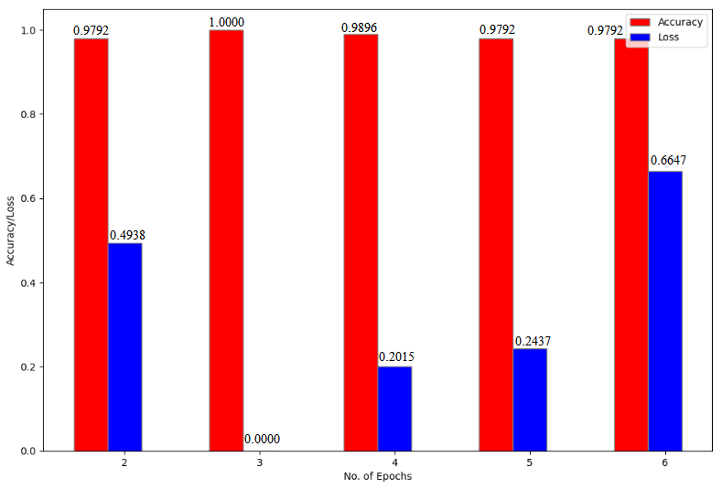

**Batch Size**

***Average Time per Epoch***

* 16: 216.00
* 24: 216.00
* 32: 209.50
* 40: 207.50
* 48: 215.00

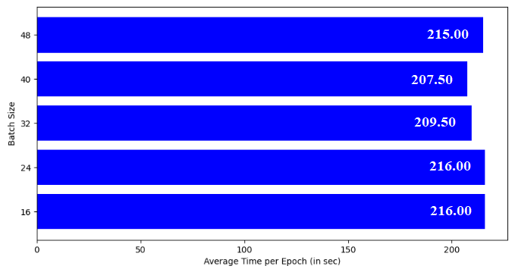

***Precision, Recall, f1 Score*** *(0: Early Blight, 1: Late Blight, 2: Healthy)*

|  |  |  |  |  |  |  |  |  |  |  |  |  |
| --- | --- | --- | --- | --- | --- | --- | --- | --- | --- | --- | --- | --- |
| **Batch Size** | **Precision** | | | | **Recall** | | | | **f1 Score** | | | |
| **0** | **1** | **2** | **Weighted Average** | **0** | **1** | **2** | **Weighted Average** | **0** | **1** | **2** | **Weighted Average** |
| 16 | 1.00 | 1.00 | 0.98 | 0.99 | 1.00 | 0.98 | 1.00 | 0.99 | 1.00 | 0.99 | 0.99 | 0.99 |
| 24 | 1.00 | 0.98 | 1.00 | 0.99 | 0.99 | 1.00 | 1.00 | 0.99 | 0.99 | 0.99 | 1.00 | 0.99 |
| 32 | 1.00 | 0.97 | 1.00 | 0.99 | 0.98 | 1.00 | 0.98 | 0.99 | 0.99 | 0.99 | 0.99 | 0.99 |
| 40 | 1.00 | 1.00 | 0.94 | 0.98 | 1.00 | 0.94 | 1.00 | 0.98 | 1.00 | 0.97 | 0.97 | 0.98 |
| 48 | 0.97 | 0.99 | 1.00 | 0.98 | 1.00 | 0.97 | 0.99 | 0.98 | 0.98 | 0.98 | 0.99 | 0.98 |

***Accuracy and Loss***

* 16: 0.9937, 0.0409
* 24: 0.9940, 0.0385
* 32: 0.9896, 0.0248
* 40: 0.9800, 0.5060
* 48: 0.9844, 0.6685

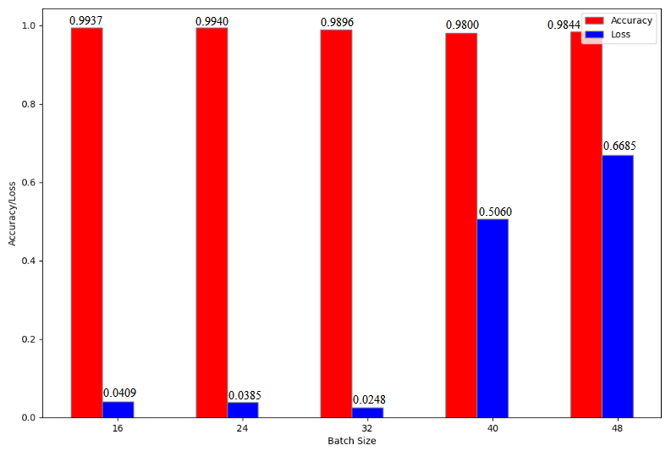

**Dataset Split Ratio**

***Average Time per Epoch***

* 90-5-5: 226.50 s
* 80-10-10: 210.50 s
* 70-15-15: 202.50 s
* 60-20-20: 190.50 s
* 50-25-25: 174.50 s

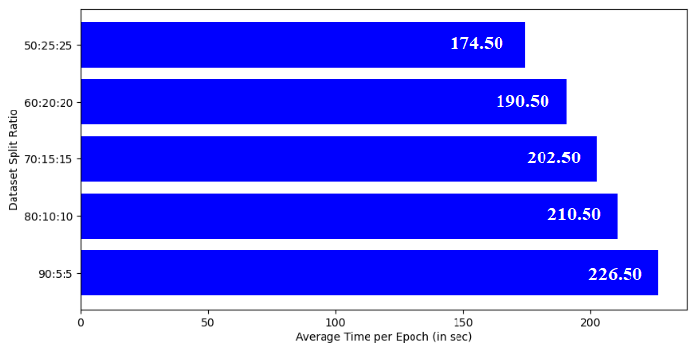

***Precision, Recall, f1 Score*** *(0: Early Blight, 1: Late Blight, 2: Healthy)*

|  |  |  |  |  |  |  |  |  |  |  |  |  |
| --- | --- | --- | --- | --- | --- | --- | --- | --- | --- | --- | --- | --- |
| **Dataset Split Ratio** | **Precision** | | | | **Recall** | | | | **f1 Score** | | | |
| **0** | **1** | **2** | **Weighted Average** | **0** | **1** | **2** | **Weighted Average** | **0** | **1** | **2** | **Weighted Average** |
| 90:5:5 | 0.98 | 1.00 | 1.00 | 0.99 | 1.00 | 0.97 | 1.00 | 0.99 | 0.99 | 0.98 | 1.00 | 0.99 |
| 80:10:10 | 1.00 | 0.93 | 1.00 | 0.98 | 0.95 | 1.00 | 0.99 | 0.98 | 0.98 | 0.96 | 0.99 | 0.98 |
| 70:15:15 | 0.98 | 0.98 | 1.00 | 0.98 | 1.00 | 0.98 | 0.98 | 0.98 | 0.99 | 0.98 | 0.99 | 0.98 |
| 60:20:20 | 0.99 | 0.98 | 0.98 | 0.98 | 0.98 | 0.97 | 1.00 | 0.98 | 0.99 | 0.98 | 0.99 | 0.98 |
| 50:25:25 | 0.99 | 0.99 | 1.00 | 0.99 | 0.99 | 0.99 | 0.99 | 0.99 | 0.99 | 0.99 | 1.00 | 0.99 |

***Accuracy and Loss***

* 90-5-5: 0.9896, 0.0337
* 80-10-10: 0.9792, 0.0502
* 70-15-15: 0.9844, 0.0900
* 60-20-20: 0.9844, 0.1319
* 50-25-25: 0.9903, 0.4449

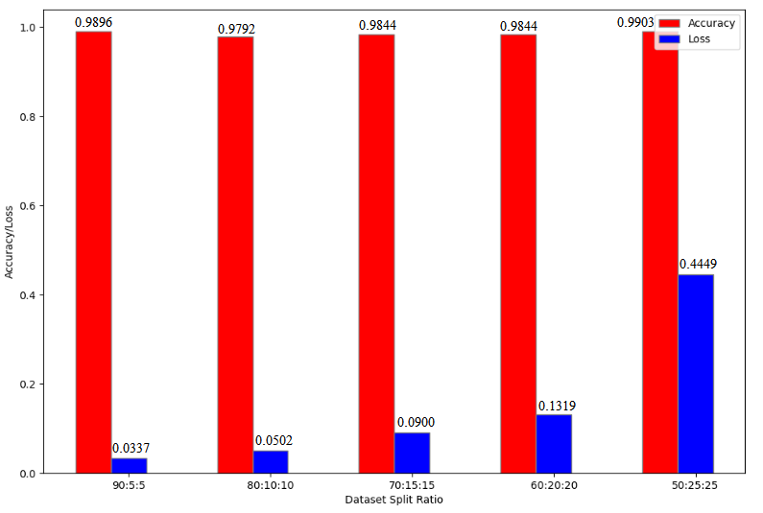

**MODEL 5: InceptionV3**

**No. of Epochs**

***Average Time per Epoch***

* 10: 40.80 s
* 15: 39.73 s
* 20: 40.35 s
* 25: 41.04 s
* 30: 41.13 s

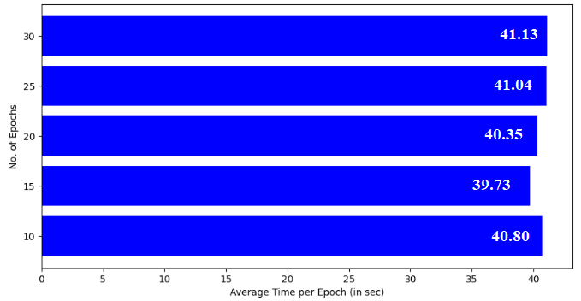

***Precision, Recall, f1 Score*** *(0: Early Blight, 1: Late Blight, 2: Healthy)*

|  |  |  |  |  |  |  |  |  |  |  |  |  |
| --- | --- | --- | --- | --- | --- | --- | --- | --- | --- | --- | --- | --- |
| **No. of Epochs** | **Precision** | | | | **Recall** | | | | **f1 Score** | | | |
| **0** | **1** | **2** | **Weighted Average** | **0** | **1** | **2** | **Weighted Average** | **0** | **1** | **2** | **Weighted Average** |
| 10 | 0.94 | 0.88 | 0.98 | 0.94 | 0.97 | 0.97 | 0.87 | 0.93 | 0.95 | 0.92 | 0.92 | 0.93 |
| 15 | 0.98 | 0.91 | 0.99 | 0.96 | 0.96 | 0.96 | 0.96 | 0.96 | 0.97 | 0.93 | 0.98 | 0.96 |
| 20 | 0.97 | 0.98 | 0.96 | 0.97 | 0.97 | 0.95 | 0.99 | 0.97 | 0.97 | 0.97 | 0.97 | 0.97 |
| 25 | 0.97 | 0.95 | 0.98 | 0.97 | 1.00 | 0.95 | 0.95 | 0.97 | 0.98 | 0.95 | 0.97 | 0.97 |
| 30 | 0.99 | 0.94 | 0.90 | 0.94 | 0.97 | 0.86 | 0.98 | 0.94 | 0.98 | 0.90 | 0.94 | 0.94 |

***Accuracy and Loss***

* 10: 0.9323, 2.5883
* 15: 0.9635, 1.8479
* 20: 0.9688, 1.1423
* 25: 0.9688, 1.2008
* 30: 0.9427, 1.7890

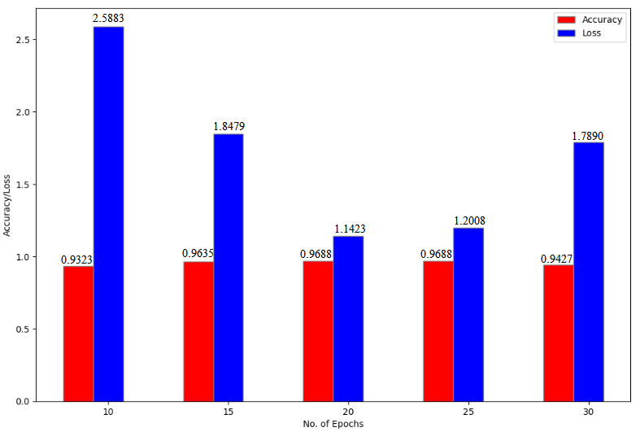

**Batch Size**

***Average Time per Epoch***

* 16: 46.33 s
* 24: 43.40 s
* 32: 43.60 s
* 40: 46.67 s
* 48: 44.73 s

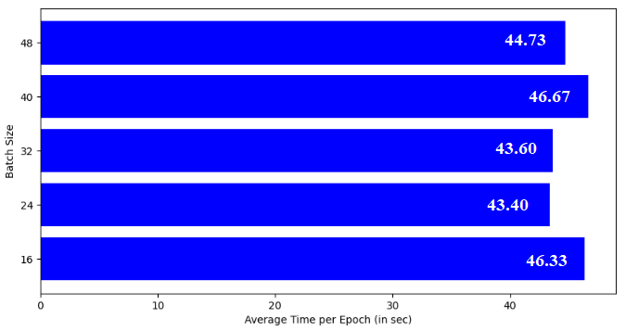

***Precision, Recall, f1 Score*** *(0: Early Blight, 1: Late Blight, 2: Healthy)*

|  |  |  |  |  |  |  |  |  |  |  |  |  |
| --- | --- | --- | --- | --- | --- | --- | --- | --- | --- | --- | --- | --- |
| **Batch Size** | **Precision** | | | | **Recall** | | | | **f1 Score** | | | |
| **0** | **1** | **2** | **Weighted Average** | **0** | **1** | **2** | **Weighted Average** | **0** | **1** | **2** | **Weighted Average** |
| 16 | 0.98 | 0.89 | 1.00 | 0.96 | 1.00 | 0.98 | 0.89 | 0.96 | 0.99 | 0.93 | 0.94 | 0.96 |
| 24 | 1.00 | 0.95 | 0.92 | 0.95 | 0.96 | 0.91 | 0.98 | 0.95 | 0.98 | 0.93 | 0.95 | 0.95 |
| 32 | 0.98 | 0.94 | 0.95 | 0.96 | 0.95 | 0.95 | 0.97 | 0.96 | 0.97 | 0.95 | 0.96 | 0.96 |
| 40 | 1.00 | 0.84 | 0.98 | 0.95 | 0.96 | 0.98 | 0.89 | 0.94 | 0.98 | 0.91 | 0.93 | 0.94 |
| 48 | 0.96 | 0.92 | 0.92 | 0.93 | 0.95 | 0.91 | 0.94 | 0.93 | 0.95 | 0.92 | 0.93 | 0.93 |

***Accuracy and Loss***

* 16: 0.9563, 2.9272
* 24: 0.9524, 2.4602
* 32: 0.9583, 3.2515
* 40: 0.9400, 3.2511
* 48: 0.9323, 1.7262

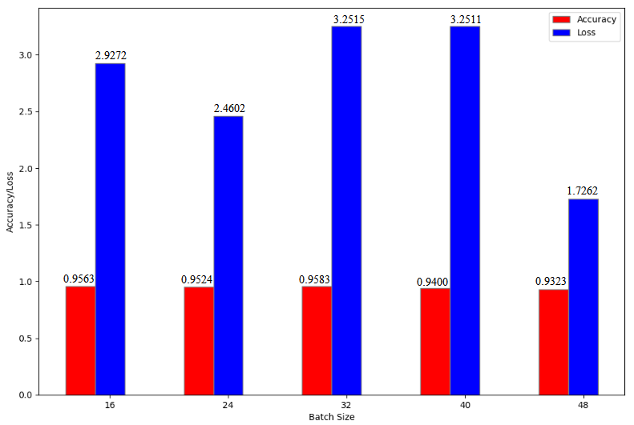

**Dataset Split Ratio**

***Average Time per Epoch***

* 90-5-5: 44.80 s
* 80-10-10: 41.20 s
* 70-15-15: 39.67 s
* 60-20-20: 37.80 s
* 50-25-25: 34.33 s

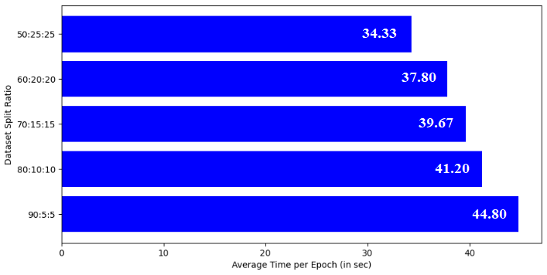

***Precision, Recall, f1 Score*** *(0: Early Blight, 1: Late Blight, 2: Healthy)*

|  |  |  |  |  |  |  |  |  |  |  |  |  |
| --- | --- | --- | --- | --- | --- | --- | --- | --- | --- | --- | --- | --- |
| **Dataset Split Ratio** | **Precision** | | | | **Recall** | | | | **f1 Score** | | | |
| **0** | **1** | **2** | **Weighted Average** | **0** | **1** | **2** | **Weighted Average** | **0** | **1** | **2** | **Weighted Average** |
| 90:5:5 | 0.97 | 1.00 | 0.97 | 0.98 | 1.00 | 0.93 | 1.00 | 0.98 | 0.98 | 0.97 | 0.99 | 0.98 |
| 80:10:10 | 0.98 | 0.92 | 0.96 | 0.95 | 0.96 | 1.00 | 0.90 | 0.95 | 0.97 | 0.96 | 0.93 | 0.95 |
| 70:15:15 | 0.93 | 0.96 | 0.96 | 0.95 | 0.98 | 0.90 | 0.97 | 0.95 | 0.96 | 0.93 | 0.96 | 0.95 |
| 60:20:20 | 0.91 | 0.91 | 0.88 | 0.90 | 0.99 | 0.84 | 0.86 | 0.90 | 0.95 | 0.87 | 0.87 | 0.90 |
| 50:25:25 | 0.95 | 0.88 | 0.94 | 0.92 | 0.96 | 0.92 | 0.88 | 0.92 | 0.95 | 0.90 | 0.91 | 0.92 |

***Accuracy and Loss***

* 90-5-5: 0.9792, 0.5846
* 80-10-10: 0.9531, 2.3687
* 70-15-15: 0.9492, 3.2283
* 60-20-20: 0.9000, 4.2928
* 50-25-25: 0.9199, 4.8327

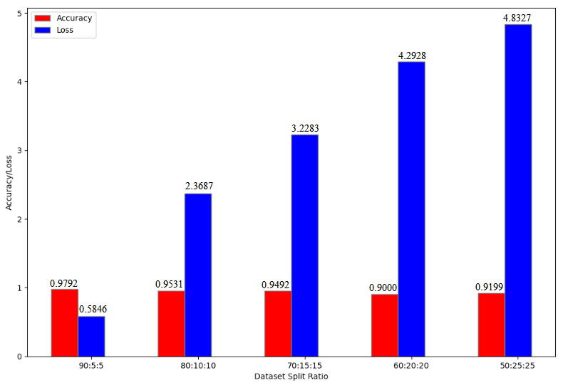

**MODEL 6: AlexNet**

**No. of Epochs**

***Average Time per Epoch***

* 20: 50.30 s
* 25: 51.52 s
* 30: 50.30 s
* 35: 49.26 s
* 40: 51.50 s

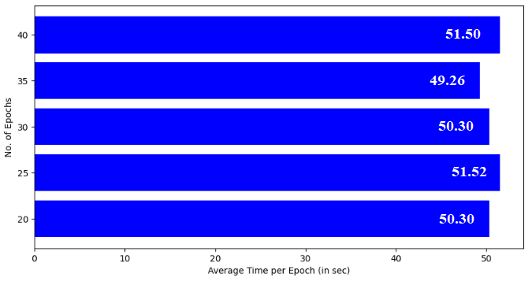

***Precision, Recall, f1 Score*** *(0: Early Blight, 1: Late Blight, 2: Healthy)*

|  |  |  |  |  |  |  |  |  |  |  |  |  |
| --- | --- | --- | --- | --- | --- | --- | --- | --- | --- | --- | --- | --- |
| **No. of Epochs** | **Precision** | | | | **Recall** | | | | **f1 Score** | | | |
| **0** | **1** | **2** | **Weighted Average** | **0** | **1** | **2** | **Weighted Average** | **0** | **1** | **2** | **Weighted Average** |
| 20 | 1.00 | 0.72 | 1.00 | 0.91 | 0.86 | 1.00 | 0.75 | 0.87 | 0.93 | 0.83 | 0.85 | 0.87 |
| 25 | 1.00 | 0.92 | 0.97 | 0.97 | 0.92 | 0.98 | 0.98 | 0.96 | 0.96 | 0.95 | 0.98 | 0.96 |
| 30 | 0.98 | 0.96 | 0.98 | 0.97 | 0.96 | 0.97 | 0.98 | 0.97 | 0.97 | 0.97 | 0.98 | 0.97 |
| 35 | 0.98 | 1.00 | 0.98 | 0.99 | 1.00 | 0.97 | 1.00 | 0.99 | 0.99 | 0.98 | 0.99 | 0.99 |
| 40 | 0.95 | 0.95 | 0.97 | 0.96 | 0.97 | 0.94 | 0.97 | 0.96 | 0.96 | 0.94 | 0.97 | 0.96 |

***Accuracy and Loss***

* 20: 0.8698, 0.3773
* 25: 0.9635, 0.0635
* 30: 0.9740, 0.0600
* 35: 0.9896, 0.0366
* 40: 0.9583, 0.1699

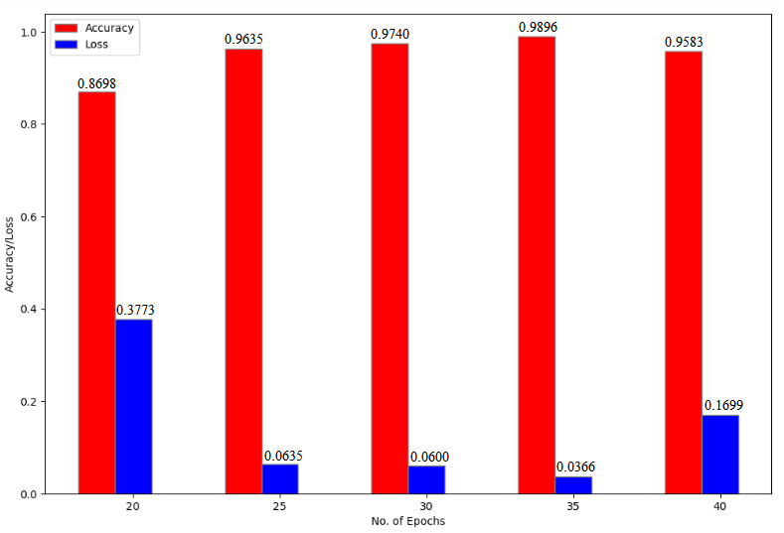

**Batch Size**

***Average Time per Epoch***

* 16: 60.20 s
* 24: 54.40 s
* 32: 53.05 s
* 40: 52.50 s
* 48: 49.85 s

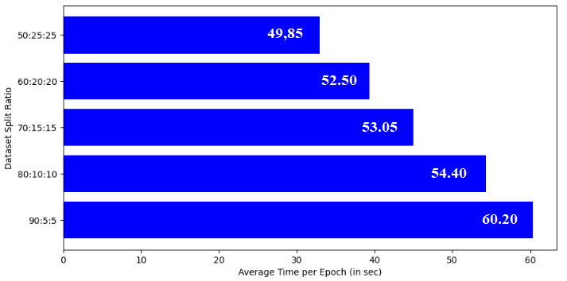

***Precision, Recall, f1 Score*** *(0: Early Blight, 1: Late Blight, 2: Healthy)*

|  |  |  |  |  |  |  |  |  |  |  |  |  |
| --- | --- | --- | --- | --- | --- | --- | --- | --- | --- | --- | --- | --- |
| **Batch Size** | **Precision** | | | | **Recall** | | | | **f1 Score** | | | |
| **0** | **1** | **2** | **Weighted Average** | **0** | **1** | **2** | **Weighted Average** | **0** | **1** | **2** | **Weighted Average** |
| 16 | 0.94 | 0.98 | 0.97 | 0.96 | 0.98 | 0.91 | 1.00 | 0.96 | 0.96 | 0.94 | 0.98 | 0.96 |
| 24 | 1.00 | 0.96 | 0.96 | 0.97 | 0.98 | 0.97 | 0.96 | 0.97 | 0.99 | 0.96 | 0.96 | 0.97 |
| 32 | 1.00 | 0.94 | 1.00 | 0.98 | 0.97 | 1.00 | 0.97 | 0.98 | 0.98 | 0.97 | 0.99 | 0.98 |
| 40 | 1.00 | 0.94 | 1.00 | 0.98 | 0.94 | 1.00 | 0.98 | 0.97 | 0.97 | 0.97 | 0.99 | 0.98 |
| 48 | 1.00 | 0.69 | 0.98 | 0.90 | 0.81 | 1.00 | 0.81 | 0.86 | 0.89 | 0.91 | 0.89 | 0.87 |

***Accuracy and Loss***

* 16: 0.9625, 0.1788
* 24: 0.9702, 0.0936
* 32: 0.9792, 0.0629
* 40: 0.9750, 0.0780
* 48: 0.8646, 0.4008

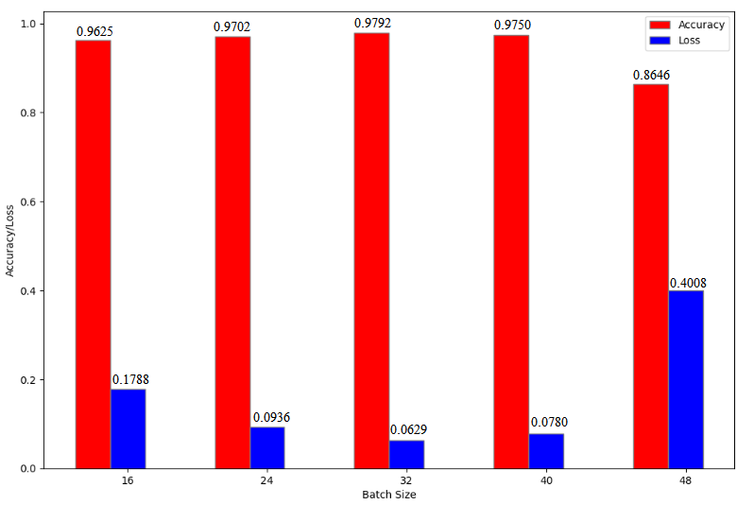

**Dataset Split Ratio**

***Average Time per Epoch***

* 90-5-5: 60.35 s
* 80-10-10: 54.35 s
* 70-15-15: 45.00 s
* 60-20-20: 39.35 s
* 50-25-25: 32.95 s

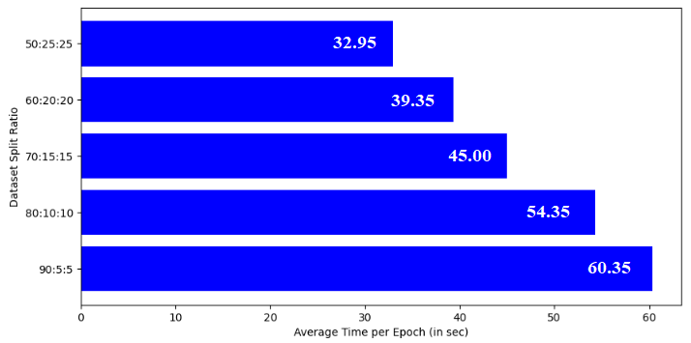

***Precision, Recall, f1 Score*** *(0: Early Blight, 1: Late Blight, 2: Healthy)*

|  |  |  |  |  |  |  |  |  |  |  |  |  |
| --- | --- | --- | --- | --- | --- | --- | --- | --- | --- | --- | --- | --- |
| **Dataset Split Ratio** | **Precision** | | | | **Recall** | | | | **f1 Score** | | | |
| **0** | **1** | **2** | **Weighted Average** | **0** | **1** | **2** | **Weighted Average** | **0** | **1** | **2** | **Weighted Average** |
| 90:5:5 | 1.00 | 0.98 | 0.97 | 0.98 | 1.00 | 0.98 | 0.97 | 0.98 | 1.00 | 0.98 | 0.97 | 0.98 |
| 80:10:10 | 1.00 | 0.91 | 0.98 | 0.97 | 0.97 | 0.98 | 0.94 | 0.96 | 0.98 | 0.95 | 0.96 | 0.96 |
| 70:15:15 | 0.98 | 0.65 | 1.00 | 0.87 | 0.75 | 0.99 | 0.67 | 0.81 | 0.85 | 0.79 | 0.80 | 0.81 |
| 60:20:20 | 0.94 | 0.94 | 0.95 | 0.94 | 0.95 | 0.92 | 0.96 | 0.94 | 0.95 | 0.93 | 0.95 | 0.94 |
| 50:25:25 | 0.99 | 0.81 | 0.99 | 0.93 | 0.82 | 0.99 | 0.95 | 0.92 | 0.90 | 0.89 | 0.97 | 0.92 |

***Accuracy and Loss***

* 90-5-5: 0.9792, 0.0297
* 80-10-10: 0.9635, 0.0860
* 70-15-15: 0.8086, 0.7333
* 60-20-20: 0.9438, 0.1997
* 50-25-25: 0.9175, 0.2516

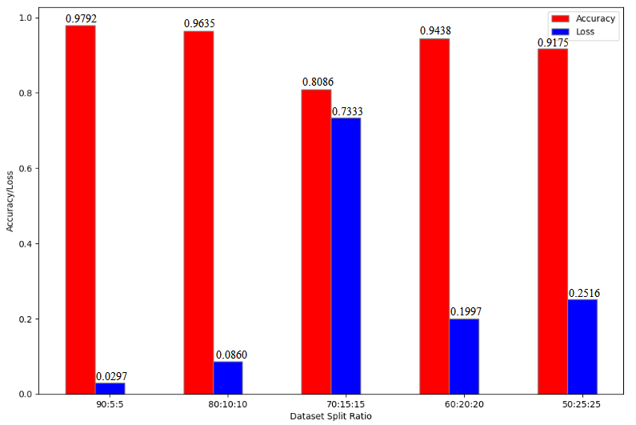

**COMPARISON BASED ON DATASETS (BASE MODELS)**

***Misclassification Percentage***

|  |  |  |
| --- | --- | --- |
| **MODEL** | **Dataset 1** | **Dataset 2** |
| **CNN** | 6.09% | 4.44% |
| **ResNet50** | 0.00% | 0.00% |
| **VGG16** | 0.54% | 0.00% |
| **VGG19** | 1.82% | 2.17% |
| **InceptionV3** | 3.23% | 3.66% |
| **AlexNet** | 10.45% | 13.01% |

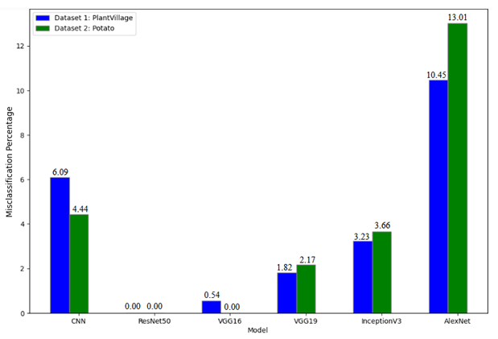

***Accuracy***

|  |  |  |
| --- | --- | --- |
| **MODEL** | **Dataset 1** | **Dataset 2** |
| **CNN** | 0.9258 | 0.9583 |
| **ResNet50** | 1.0000 | 1.0000 |
| **VGG16** | 0.9922 | 1.0000 |
| **VGG19** | 0.9922 | 0.9792 |
| **InceptionV3** | 0.9766 | 0.9635 |
| **AlexNet** | 0.9336 | 0.8698 |

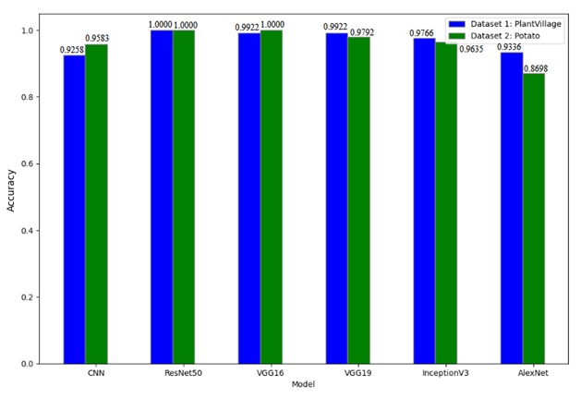

***Loss***

|  |  |  |
| --- | --- | --- |
| **MODEL** | **Dataset 1** | **Dataset 2** |
| **CNN** | 0.2212 | 0.1152 |
| **ResNet50** | 0.0046 | 0.0049 |
| **VGG16** | 0.1107 | 0.0016 |
| **VGG19** | 0.0926 | 0.4938 |
| **InceptionV3** | 1.5436 | 1.8479 |
| **AlexNet** | 0.2237 | 0.3773 |

